To: Arts/Culture/Features Editor

FOR IMMEDIATE RELEASE 15 September 2017

Press Release
****************************************************************************************
1st Hong Kong International Conducting Competition
Candidates announced

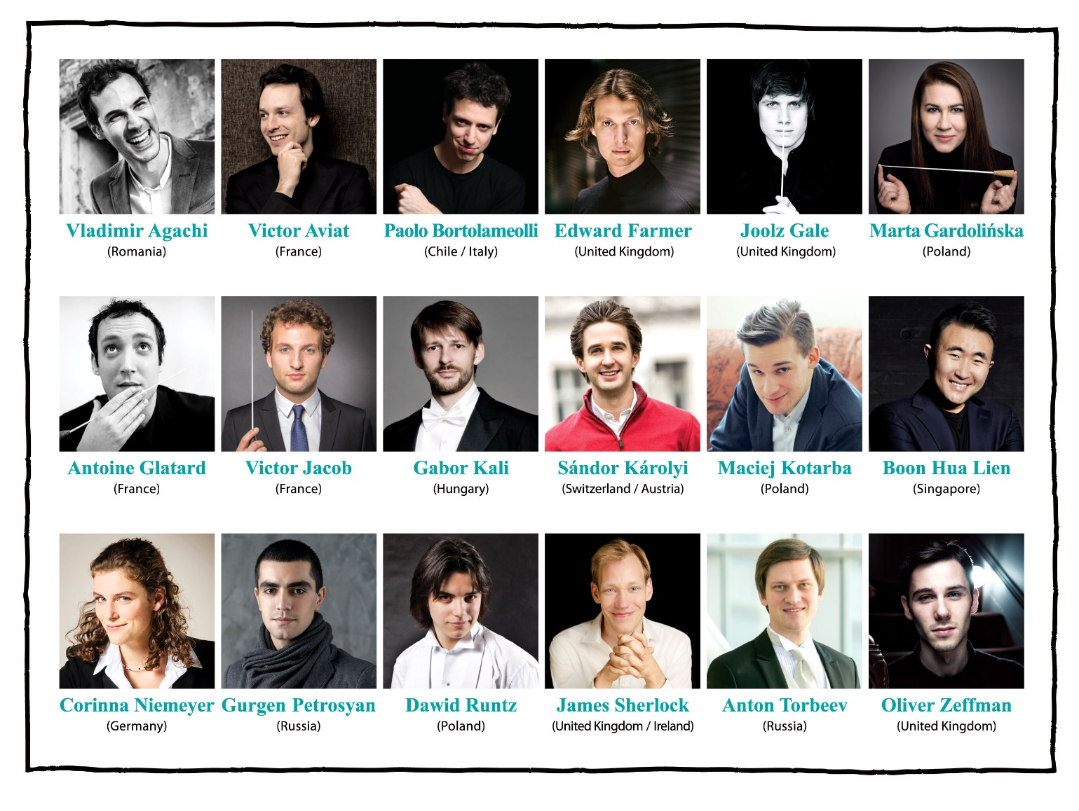
Hong Kong Sinfonietta is presenting the 1st Hong Kong International Competition with the aim of providing a platform for young conductors (under the age of 35) to establish an international network in Asia. We are announcing the 18 candidates who will compete in the Competition in January 2018.

Chosen from 310 applications from 49 countries/regions, the 18 candidates are from Austria, Chile, France, Germany, Hungary, Ireland, Italy, Poland, Romania, Russia, Singapore, Switzerland and the United Kingdom.

The 1st Hong Kong International Competition attracted 310 applications from 49 countries/regions.
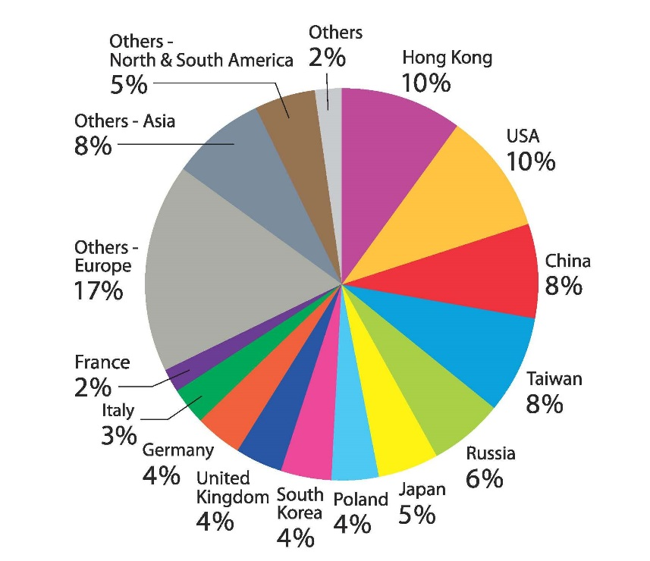
Co-chair of the Jury Yip Wing-sie (Music Director, Hong Kong Sinfonietta) says, “we are thrilled with the overwhelming response. The standards of the applicants are very high and it was a tough job shortlisting the final candidates”. The other jury members of the preliminary selection round were Co-chair Christoph Poppen (Principal Guest Conductor, Hong Kong Sinfonietta; Principal Conductor, Cologne Chamber Orchestra) and James Cuddeford (Concertmaster, Hong Kong Sinfonietta).

The 18 candidates who will compete in Round 1 are:

- Vladimir AGACHI (Romania│age: 35)
- Victor AVIAT (France│age: 35)
- Paolo BORTOLAMEOLLI (Chile/Italy│age: 34)
- Edward FARMER (United Kingdom│age: 32)
- Joolz GALE (United Kingdom│age: 34)
- Marta GARDOLIŃSKA (Poland│age: 28)
- Antoine GLATARD (France│age: 33)
- Victor JACOB (France│age: 26)
- Gabor KALI (Hungary│age: 35)
- Sándor Károlyi (Switzerland/Austria│age: 27)
- Maciej Kotarba (Poland│age: 26)
- Boon Hua LIEN (Singapore│age: 32)
- Corinna NIEMEYER (Germany│age: 31)
- Gurgen PETROSYAN (Russia│age: 25)
- Dawid RUNTZ (Poland│age: 25)
- James SHERLOCK (United Kingdom /Ireland│age: 34)
- Anton TORBEEV (Russia│age: 32)
- Oliver ZEFFMAN (United Kingdom│age: 24)

Candidate details: https://www.hkconducting.com/candidates.html

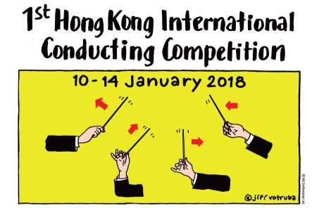
The 1st Hong Kong International Conducting Competition will be held at the Hong Kong City Hall Concert Hall from 10 to 14 January 2018. It comprises three rounds in which the candidates will conduct programmes that include a work by Hong Kong composer Chan Hing-yan (HKS Artist Associate 2016-2018) and a concerto featuring Hong Kong pianist Colleen Lee (HKS Artist Associate 2010-2011). An international Jury made up of renowned conductors and professionals in the field – Co-chairs Yip Wing-sie and Christoph Poppen, Jorma Panula (Director/Professor in Conducting, Panula Academy), Chien Wen-pin (Conductor, Deutsche Oper am Rhein; Executive & Artistic Director designée, National Kaohsiung Center for the Arts, Taiwan), Gaetan Le Divelec (Director, Askonas Holt), Gavin Reid (Chief Executive, Scottish Chamber Orchestra), and Lam Wing-tsan (Principal Tuba, Hong Kong Sinfonietta) – will select the prizewinners.

The prizes
1st Prize | HK$150,000 + concert engagement with Hong Kong Sinfonietta and apprenticeship possibilities with Christoph Poppen and Chien Wen-pin in Germany/Taiwan
2nd Prize | HK$80,000
3rd Prize | HK$50,000
Audience Prize | HK$10,000
Orchestra Prize | HK$10,000

All rounds of the Competition are open to the public and tickets will be available at URBTIX outlets starting 28 October 2017.

10 January 2018: Round 1 (a maximum of 18 candidates)
- Beethoven: Egmont Overture, Op 84
- One of the following overtures:
Weber: Der Freischütz Overture
Rossini: The Barber of Seville Overture

11-12 January 2018: Round 2 – Semi-Finals (a maximum of 8 semi-finalists)
- Bartók: Divertimento
- Chopin: Piano Concerto No 2 in F minor, Op 21: II Larghetto (Soloist: Colleen Lee)
- One of the following symphonies:
Beethoven: Symphony No 5 in C minor, Op 67
Brahms: Symphony No 3 in F, Op 90
Schumann: Symphony No 1 in B-flat, Op 38, “Spring”

14 January 2018: Round 3 – Finals (a maximum of 3 finalists)
- Chan Hing-yan (HKS Artist Associate): commissioned work November Leonids for Orchestra
- One of the following symphonies:
Beethoven: Symphony No 5 in C minor, Op 67
Brahms: Symphony No 3 in F, Op 90
Schumann: Symphony No 1 in B-flat, Op 38, “Spring”
- The finalists will also be invited to make a short presentation to the audience.

For more information, please visit:
www.hkconducting.com
https://www.facebook.com/hkconducting/

Hong Kong Sinfonietta is financially supported by the Government of the Hong Kong Special Administrative Region
Hong Kong Sinfonietta is the Venue Partner of the Hong Kong City Hall

****************************************************************************************
Media Enquiry
Senior Marketing & Development Manager, Hong Kong Sinfonietta
Amanda Mok
Email: amanda.mok@hksinfonietta.org
Direct Line: +852 3607 2328
Mobile: +852 9727 1808

###

