To: Arts/Culture/Features Editor

For immediate release

25 June 2018
Press Release
***************************************************************************************
Hong Kong Sinfonietta Launches HKS Cool Summer Festival
Crossover Performances Spark Audience’s Passion for Classical Music

Hong Kong Sinfonietta will hold its first HKS Cool Summer Festival from 20 July to 18 August 2018, collaborating with Artist Associate Leon Ko, conductor Jason Lai, rock band Chochukmo and Austrian Jazz star Georg Breinschmid. The Festival will feature a series of concerts that include film music, jazz and a rock music programme for audience members to “cool” down with live music in the scorching summer heat.

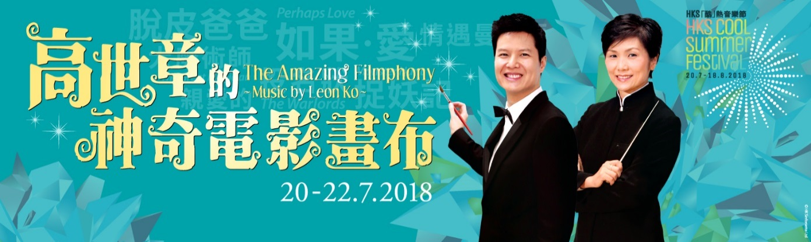
The Amazing Filmphony (20-22 July, HK City Hall Concert Hall)
Hong Kong Sinfonietta and Music Director Yip Wing-sie will collaborate with this season’s Artist Associate and prolific film and musical composer Leon Ko to kick-start the HKS Cool Summer Festival. Leon Ko will be painting on his magical music canvas works from movies such as Perhaps Love, The Warlords, The Great Magician and Monster Hunt, turning them into a theatrical symphony for singers and the orchestra! His award-winning scores and songs, led by Music Director Yip Wing-sie and sung by four acclaimed singers, Margaret Cheung, Jordan Cheng, Jarita Wan and Rick Lau, will take the audience through an emotional and unforgettable soundscape journey.

Sounds Great! Classical Music in Movies (3-5 August, HK City Hall Concert Hall)
Hong Kong Sinfonietta will continue the hype for movie music and collaborate with conductor Jason Lai to present excerpts of classical masterpieces in movies, including Richard Strauss’ Also Sprach Zarathustra, Wagner’s Ride of the Valkyries, Mozart’s Clarinet Concerto in A, Tchaikovsky’s Romeo & Juliet Fantasy Overture and John Williams’ Star Wars. It is time for some movie magic! Jason Lai is passionate in promoting classical music and was Hong Kong Sinfonietta’s Assoicate Conductor in 2013/2014 season. With his unique affinity, the audiences love him!

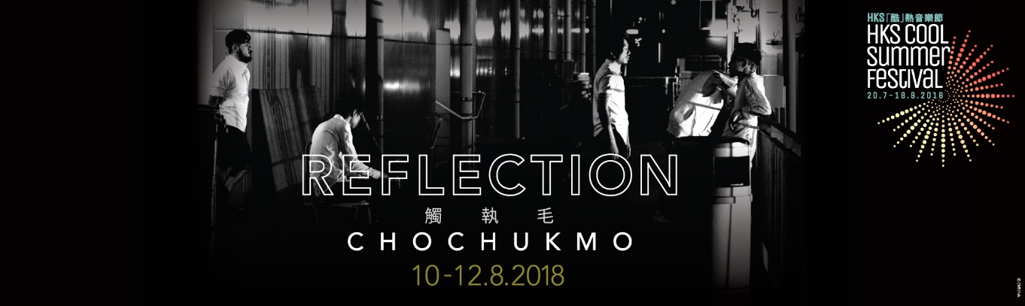

Chochukmo: Reflection (10-12 August, HK Cultural Centre Studio Theatre)
For the first time ever, local indie rock band Chochukmo collaborates with Hong Kong Sinfonietta musicians, curating a cross-disciplinary performance titles “Reflection”. The 5-piece band will join forces with the strings and brass of the orchestra, bringing the audience an eccentric musical experience of tranquility and turbulence, stillness and motion.

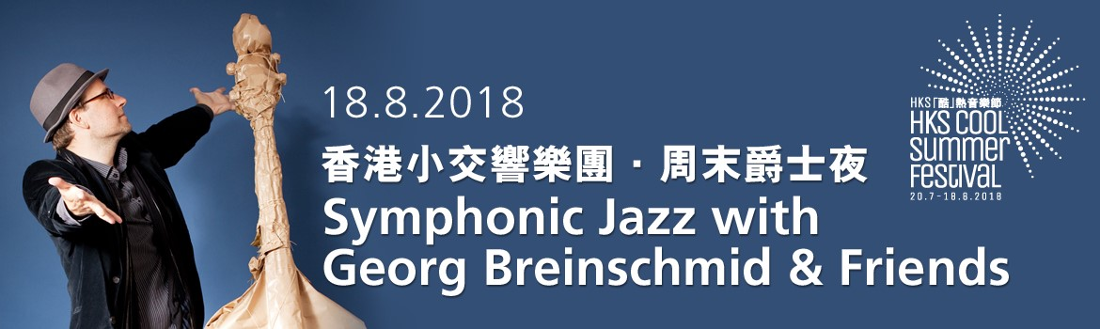

Symphonic Jazz with Georg Breinschmid & Friends (18 August, HK City Hall Concert Hall)
Austrian Jazz star Georg Breinschmid was a double bass player in the Vienna Philharmonic before he started engaging in Jazz music. His humorous music style is deeply loved by audiences, and has made him one of the most important figures in the European Jazz world today. He will be collaborating with Hong Kong Sinfonietta, along with his music partners, to present some of his own Jazz works and surprising improvisations.

For festival’s programme details, please visit www.HKSL.org/summer

**************************************************************************************
Hong Kong Sinfonietta Cool Summer Festival

The Amazing Filmphony
Music: Leon Ko
Staging: Yuri Ng
Music Director/ Conductor: Yip Wing-sie
Singers: Jarita Wan, Margaret Cheung, Jordan Cheng, Rick Lau
20-21 July 2018 (Fri-Sat) 8pm
22 July 2018 (Sun) 3pm
HK City Hall Concert Hall
Tickets: $380 $260 $150

Sounds Great! Classical Music in Movies
Conductor: Jason Lai
Clarinet: Fong Hiu-kai Johnny
3-4 Aug 2018 (Fri-Sat) 8pm
5 Aug 2018 (Sun) 3pm
HK City Hall Concert Hall
Tickets: $380 $260 $150

Chochukmo: Reflection
10-12 Aug 2018 (Fri-Sun) 8pm
HK Cultural Centre Studio Theatre
Tickets: $380 $280

Symphonic Jazz with Georg Breinschmid & Friends
Conductor: Roderick Dunk
Double Bass: Georg Breinschmid
Violin: Florian Willeitner
Piano: Antoni Donchev
18 Aug 2018 (Sat) 8pm
HK City Hall Concert Hall
Tickets: $380 $260 $150

Tickets are now available for sale at all URBTIX outlets.
Ticketing Enquiries: 2111 5999; URBTIX Internet Ticketing Service: www.URBTIX.hk

Festival Discount Offers:
Get a 20% discount when you purchase full-price tickets to all FOUR of the Festival programmes; a 15% discount to THREE of them; or a 10% to any TWO of them

For Festival details: www.HKSL.org/summer

Half-price tickets available for full-time students, senior citizens, people with disabilities and CSSA recipients.
10% discount for group booking of 4 or more adult tickets.

Hong Kong Sinfonietta is financially supported by the Government of the Hong Kong Special Administrative Region
Hong Kong Sinfonietta is the Venue Partner of the Hong Kong City Hall.

Programme Enquiry: 2836 3336/ info@hksinfonietta.org
Website: www.HKSL.org

**********************************************************************************
Media Enquiry
Amanda Mok
Senior Marketing & Business Development Manager
Hong Kong Sinfonietta
Email: amanda.mok@hksinfonietta.org
Direct Line: +852 3607 2328
Mobile : +852 9727 1808

