To: Arts/Culture/Features Editor

FOR IMMEDIATE RELEASE
5 June 2019
Press Release
***************************************************************************************
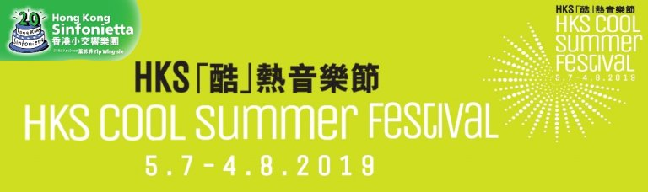
The HKS Cool Summer Festival is back! After last year’s resounding success, Hong Kong Sinfonietta has brought back the HKS Cool Summer Festival and will be featuring three fantastic new programmes between 5th July and 4th August 2019. Across three series of concerts, they will be joining forces with star tuba player Thomas Leleu, this season’s HKS Artist Associate McDull, and established West End singer John Langley alongside Hong Kong local musical theatre artists, performing a dazzling array of innovative and exciting programmes.

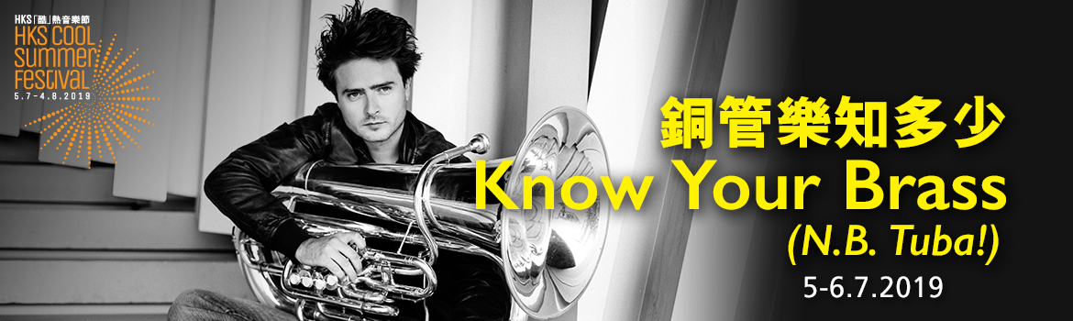

Know Your Brass (N.B. Tuba!) (5-6 July, Hong Kong City Hall Concert Hall)
French tuba player Thomas Leleu and conductor Perry So will kick off this year’s HKS Cool Summer Festival with two concerts featuring two different programmes, introducing the audience to the exciting world of brass instruments. In his Hong Kong début, Leleu will be collaborating with Hong Kong Sinfonietta to perform an original programme of a mixture of little-known tuba pieces and popular symphonic works, giving the audience a taste of the dazzling brilliance of brass music. Hailed as “absolute tuba genius” by La Nouvelle République, Thomas Leleu was the first tuba player to win the coveted title of “Revelation Instrumental Soloist of the Year” at Victoires de la Musique Classique 2012. Hong Kong conductor Perry So has collaborated with orchestras around the world, from Europe to North America, Mainland China to Hong Kong, he is keen to bring classical music to the public, and is well respected and loved by his audiences.

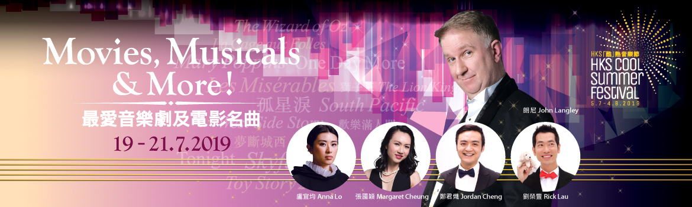

Movies, Musicals & More! (19-21 July, Hong Kong City Hall Concert Hall)
A long-time friend of Hong Kong Sinfonietta, West End singer John Langley will be sharing the stage with four local musical theatre artists Anna Lo, Margaret Cheung, Jordan Cheng and Rick Lau and Hong Kong Sinfonietta to perform some of musical theatre and film music’s best loved numbers, including iconic songs from The Wizard of Oz, West Side Story, The Lion King, Aladdin, Les Misérables, Harry Potter and more. It promises to be a memorable, beautiful musical experience!

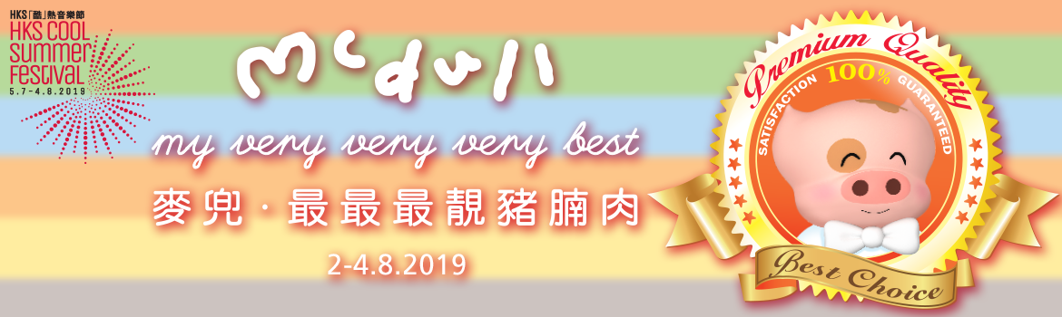

McDull my very very very best (2-4 August, Hong Kong City Hall Concert Hall)
Hong Kong’s favourite piggy McDull is a big fan of classical music, and over the past 13 years, McDull and Hong Kong Sinfonietta have collaborated again and again to touch the hearts of their audiences. Returning this season as the HKS Artist Associate, McDull and the orchestra will share their very very very favourites from the “HKS McDull Music Project” concert series. Along with Music Director Yip Wing-sie and local pianist and Artist Associate 2010-2011 Colleen Lee, Hong Kong Sinfonietta will share the music of Mozart, Beethoven, Mendelssohn, Brahms, Tchaikovsky and other classical composers through animation and stories, bringing the joys of classical music to audiences old and young.

For details of these programmes, please visit www.HKSL.org/coolsummer for more information.

**********************************************************************************

HKS Cool Summer Festival

Know Your Brass (N.B. Tuba!)
Conductor: Perry So
Tuba: Thomas Leleu
5-6 July 2019 (Fri-Sat) 8pm
Hong Kong City Hall Concert Hall
Tickets: $360, $220, $140

Movies, Musicals & More!
Conductor: Roderick Dunk
Singers: John Langley, Anna Lo, Margaret Cheung, Jordan Cheng, Rick Lau
19-20 July 2019 (Fri-Sat) 8pm
21 July 2019 (Sun) 3pm
Hong Kong City Hall Concert Hall
Tickets: $420, $260, $150

McDull my very very very best
Music Director/Conductor: Yip Wing-sie
Piano: Colleen Lee (Artist Associate 2010-2011)
Concept/Co-directors: Brian Tse & Alice Mak
Animation Production: Lunchtime Production Limited
In collaboration with: Chun Tian Hua Hua Foundation Ltd
2 August 2019 (Fri) 8pm
3-4 August 2019 (Sat-Sun) 3pm, 8pm
Hong Kong City Hall Concert Hall
Tickets: $450, $320, $180

Tickets available at URBTIX
Credit Card Booking: 2111 5999
URBTIX Internet Ticketing Service: www.URBTIX.hk
Ticketing Enquiries: 3761 6661
Programme Enquiries: 2836 3336 / info@hksinfonietta.org
Website: www.HKSL.org
For ages 6+
Enjoy a 20% discount when you purchase standard tickets to any two programmes of HKS Cool Summer Festival.

Half-price tickets available for full-time students, senior citizens, people with disabilities and the minder & Comprehensive Social Security Assistance recipients; 10% discount for group booking of 4 or more standard tickets

Hong Kong Sinfonietta is financially supported by the Government of the Hong Kong Special Administrative Region

Hong Kong Sinfonietta is the Venue Partner of the Hong Kong City Hall.

Hong Kong Sinfonietta reserves the right to change the programme and artists
**********************************************************************************
Media Enquiry
Amanda Mok
Senior Marketing & Development Manager, Hong Kong Sinfonietta
Email: amanda.mok@hksinfonietta.org
Direct Line: +852 3607 2328
Mobile : +852 9727 1808

