To: Arts/Culture/Features Editor

For immediate release

16 Nov 2020
Press Release
*********************************************************************************
Go on a journey with Hong Kong Sinfonietta & McDull
to where famous paintings meet classical music

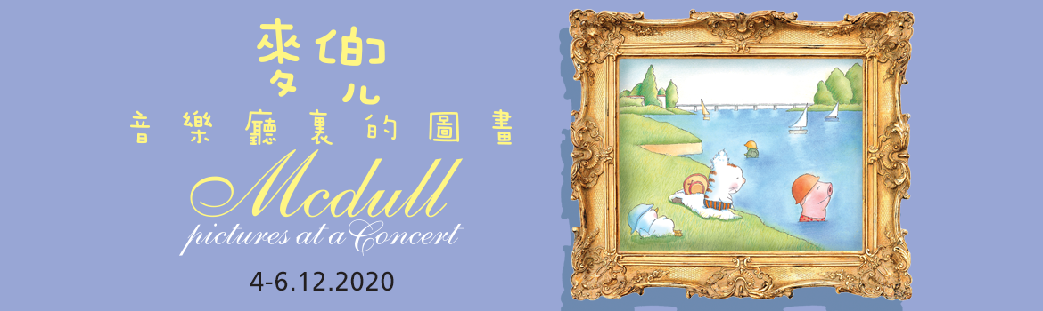

Hong Kong’s most adorable piglet McDull returns to the concert hall with Hong Kong Sinfonietta this December! From Rembrandt, Rousseau and Seurat to Mussorgsky’s Pictures at an Exhibition, Prokofiev’s Romeo and Juliet, Bach and Mahler – see how McDull and his friends hear the beauty in the pictures and see the colour in music! Backed by charming animations produced by the creators of McDull, Music Director Emeritus Yip Wing-sie and the orchestra will take you on a journey through McDull’s favourite works in this fun-filled concert that is bound to fuel your imagination.

To be held on 4-6 December at the Hong Kong City Hall Concert Hall, the programme of “McDull‧Pictures at a Concert” includes Mussorgsky’s well-loved Pictures at an Exhibition (orchestrated by Ravel), excerpts from Prokofiev’s Romeo and Juliet and Ravel’s Le Tombeau de Couperin, as well as other luminous works by Bach, Mahler, Stravinsky and Lutosławski.

Hong Kong Sinfonietta has long been a pioneer in specially designed concerts for a wide range of audiences. Through its collaboration with the popular local cartoon character McDull in the “HKS McDull Music Project” series since 2006 – which resulted in many phenomenally received concerts such as “The Carnival of a Hong Kong Cafe”, “Olympic Fanfare”, “McDull．A Sentimental Little Christmas” and “McDull．me & my mum”, as well as McDull being named HKS Artist Associate in the 2019/2020 season – the orchestra has successfully brought classical music closer to the community and audiences of all ages from all walks of life.

Disease Prevention Measures
- Audience members will need to go through temperature checks upon entering the performance venue. Those with fever symptoms will be denied entry and should seek immediate medical advice.
- Audience members must wear their own masks inside the performance venue.
- To comply with the reduced capacity and social distancing regulations of the performance venue, special seating arrangements are in place. Please sit in your assigned seats.

Ticket refund announcements will be made on the orchestra’s website and Facebook page in case of concert cancellation due to venue closure.

Hong Kong Sinfonietta
McDull‧Pictures at a Concert

4 December 2020 (Fri) 7:30pm
5-6 December 2020 (Sat & Sun) 3pm
HK City Hall Concert Hall
$420, $280, $160 (Tickets at URBTIX)

Music Director Emeritus/Conductor: Yip Wing-sie
Concept/Co-directors: Brian Tse & Alice Mak
Voice Artist: Yuri Ng
Animation Production: Lunchtime Production Limited
In collaboration with: Chun Tian Hua Hua Foundation Ltd

Programme
Stravinsky | Suite No 2 for Small Orchestra: IV Galop
Bach | Brandenburg Concerto No 3 in G, BWV1048: I Allegro
Ravel | Le Tombeau de Couperin: III Menuet
Lutosławski | Overture for Strings
Prokofiev | Romeo and Juliet: Juliet the Young Girl
Mahler | Symphony No 5 in C-sharp minor: IV Adagietto
Mussorgsky/Ravel orch | Pictures at an Exhibition

- Half-price tickets available for full-time students, senior citizens, people with disabilities and their minder, and Comprehensive Social Security Assistance recipients
- 10% discount for group booking of 4 or more standard tickets
- Suitable for age 6 and over

*********************************************************************************
McDull HKS Artist Associate 2019-2020

Created by Brian Tse and Alice Mak, McDull is a thoroughbred Hong Kong cartoon character. Since The Story of McDull in 2001, the sometimes silly but always moving stories of this piggy have been turned into various feature-length animations characterised by their use classical music – sometimes complemented by lyrics in Cantonese which evolved into surprisingly singable melodies, the most memorable being the song The Best Pork Belly which takes its melody from Mozart’s Piano Sonata Rondo Alla Turca. These animations have received multiple awards at international film festivals including: “Grand Prix (Feature Film)” at Festival International du Film d’Animation d’Annecy, France; “Official Competition Grand Prize (Feature Film)” at Seoul International Cartoon and Animation Festival, South Korea; “Special Jury Prize – Best Feature Film” at Montreal International Children's Film Festival, Canada; “Best Feature Film” of the Hong Kong Film Critics Society; and three “Best Animation Feature” awards at the Golden Horse Award, Taiwan.

Since 2006, McDull has been joining hands with Hong Kong Sinfonietta to present “music projects” which come in the form of concerts with original animation. The Carnival of the Animals becomes The Carnival of a Hong Kong Cafe, Die Moldau becomes The Story of Water (with a difference); Mahler is juxtaposed with Rembrandt while Wagner accompanies the exciting underground journey of Excreman… The thinking behind these concerts is the hope that, our audience, especially our younger generation, can be free from mundane daily constraints and be as jolly as McDull and his friends. We believe that the power of classical music can open up everyone’s imaginary world.

*********************************************************************************

Hong Kong Sinfonietta is financially supported by the Government of the Hong Kong Special Administrative Region
Hong Kong Sinfonietta is the Venue Partner of the Hong Kong City Hall

*********************************************************************************
Media Enquiry
Amanda Mok
Senior Marketing & Business Development Manager
Hong Kong Sinfonietta
Email: amanda.mok@hksinfonietta.org
Direct Line: +852 3607 2328
Mobile: +852 9727 1808

