To: Arts/Culture/Features Editor

For immediate release

26 October 2021
Press Release

*********************************************************************************
Alexander Ullman plays Rachmaninov in début with Hong Kong Sinfonietta
and gives a recital for Premiere Performances of Hong Kong

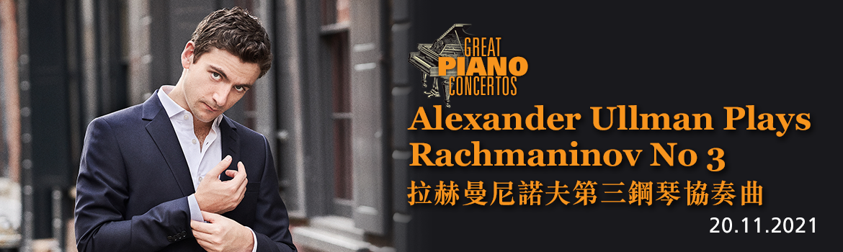
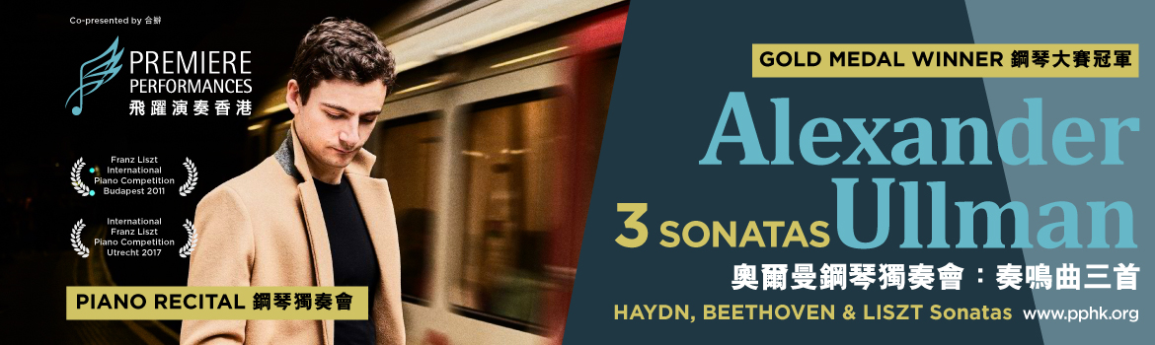
This Autumn, Hong Kong Sinfonietta and Premiere Performances of Hong Kong are delighted to continue their collaboration in bringing international artists to Hong Kong, this time featuring British rising pianist Alexander Ullman, who will be making his début with Hong Kong Sinfonietta in concert on 20 Nov plus giving a recital for Premiere Performances on 18 Nov.

Rapidly building a distinguished international profile after winning both the International Franz Liszt Piano Competitions in Budapest (2011) and Utrecht (2017), Alexander Ullman has performed at renowned venues such as London’s Wigmore Hall and Queen Elizabeth Hall, Amsterdam’s Concertgebouw, Leipzig Gewandhaus and Kennedy Center. Under the baton of Swedish conductor Ola Rudner, he brings Rachmaninov’s stunning Piano Concerto No 3 to his début with Hong Kong Sinfonietta on 20 Nov (Sat) – a programme which also includes Brahms’ enchanting Symphony No 4 and Arvo Pärt’s Cantus in Memory of Benjamin Britten. On 18 Nov (Thu), he will play sonatas by Haydn, Beethoven and Liszt in a recital organised by Premiere Performances.

Hong Kong Sinfonietta Concert

Great Piano Concertos: Alexander Ullman Plays Rachmaninov No 3

20 November 2021 (Saturday) 7:30pm
HK City Hall Concert Hall
$420, $280, $160 (Tickets at URBTIX)

Conductor: Ola Rudner
Piano: Alexander Ullman

Programme
Arvo Pärt | Cantus in Memory of Benjamin Britten (1977/1980)
Rachmaninov | Piano Concerto No 3 in D minor, Op 30
Brahms | Symphony No 4 in E minor, Op 98

Premiere Performances Recital

Alexander Ullman: 3 Sonatas
Co-presenter: Premiere Performances of Hong Kong

18 November 2021 (Thursday) 7:30pm
HK City Hall Concert Hall
$480, $320, $180 (Tickets at URBTIX)

Piano: Alexander Ullman

Programme
Haydn | Sonata in G, Hob XVI:40
Beethoven | Sonata No 21 in C, Op 53, “Waldstein”
Liszt | Sonata in B minor, S178

- Half-price tickets available for full-time students, senior citizens, people with disabilities and their minder, and Comprehensive Social Security Assistance recipients
- 10% discount for group bookings of 4 or more standard tickets
- Suitable for 6 years old or above

*********************************************************************************
Alexander Ullman Piano

Praised for his subtle interpretations and refined technical mastery, British pianist Alexander Ullman has impressed audiences and critics worldwide with his deep understanding of the scores he interprets, his elegant touch and crystalline phrasing.

Having come to international attention since winning the 2011 Franz Liszt International Piano Competition in Budapest and 2017 International Franz Liszt Piano Competition in Utrecht, Ullman was represented by the Young Classical Artists Trust from 2014 to 2017, and has appeared with the Philadelphia Orchestra, Royal Philharmonic Orchestra, Netherlands Radio Philharmonic, Norwegian Radio Orchestra, St Petersburg Philharmonic, Budapest Radio Orchestra and Korean Symphony Orchestra, as well as the New Jersey, Fort Worth and Montreal symphonies, working with conductors such as Vladimir Ashkenazy, Giancarlo Guerrero, Miguel Harth-Bedoya, Valentin Uryupin and Cristian Măcelaru.

Ullman has performed at London’s Wigmore Hall and Queen Elizabeth Hall, Amsterdam’s Concertgebouw, Leipzig Gewandhaus, Kimmel Center, Kennedy Center, Seoul Arts Center, Shanghai Oriental Arts Center and the National Centre for the Performing Arts in Beijing, and has been featured in the Nottingham and Oxford international piano series, on BBC Radio 3, France Musique and MDR Klassik. Chamber music highlights include performances at the International Musicians Seminar at Prussia Cove, Festspiele Mecklenburg-Vorpommern, Pablo Casals Festival in Prades and La Jolla Summerfest with performers such as the Dover Quartet, violinists Barnabás Kelemen and Aleksey Semenenko, and cellist Michael Petrov. In the 2017/2018 season, he closed the Lille Piano(s) Festival with Orchestre de Picardie under Jean-Claude Casadesus.

Recent highlights include performances with the National Center for the Performing Arts Orchestra in Beijing under Markus Stenz, Orquestra Simfònica de Barcelona under Josep Vicent, as well as his débuts at the Lucerne Piano Festival and Montreal Chamber Music Festival. He also made his début with the Moscow State Symphony Orchestra and performed recitals in Germany, Austria, Hungary, the Netherlands, Poland, Italy, Georgia, Mexico, Korea and his native UK.

The 2021/2022 season sees his evening recital début at Wigmore Hall and débuts with Münchner Symphoniker under Joseph Bastian and Hong Kong Sinfonietta under Ola Rudner. He also returns to the Sofia Philharmonic Orchestra, Klavierfestival Ruhr, and performs a recital for Premiere Performances Hong Kong.

In 2019, Ullman’s first album on Rubicon, featuring Tchaikovsky’s The Nutcracker Suite, Prokofiev’s Six Pieces from Cinderella, as well as Stravinsky’s Petrushka and Firebird suites, received rave reviews. In 2022, the label will release a second album featuring Liszt’s Piano Concerto No 1 and 2 with the BBC Symphony Orchestra under Andrew Litton, coupled with the composer’s Piano Sonata in B minor.

Born in London in 1991, Ullman studied at the Purcell School, the Curtis Institute and the Royal College of Music, completing his Artist Diploma as the Benjamin Britten Piano Fellow in 2017 (awarded by the Philip Loubser Foundation). His teachers have included William Fong, Leon Fleisher, Ignat Solzhenitsyn, Robert McDonald, Dmitri Alexeev, Ian Jones and Elisso Virsaladze.

*********************************************************************************

Ola Rudner Conductor

Swedish conductor Ola Rudner started his career as a high-profile violinist, having been a prizewinner of the Paganini Competition, the assistant of the legendary Sandor Vègh, and concertmaster of various orchestras such as the Camerata Salzburg, Volksoper Wien and Wiener Symphoniker. In 1995, he founded the Philharmonia Wien, and from 2001-2003, he was the Chief Conductor of the Tasmanian Symphony Orchestra in Australia. He was Chief Conductor of the Haydn Orchestra of Bolzano and Trento in 2003-2006, and the Württembergische Philharmonie Reutlingen from 2008-2016.

Since 1997, Rudner has conducted all the major Australian orchestras – the Sydney Symphony Orchestra and the orchestras of Melbourne, Queensland, Tasmania, Adelaide and Perth – while also having conducted most of the major orchestras in Scandinavia. Other orchestras he has worked with include the London Philharmonic Orchestra, BBC Symphony Orchestra, Frankfurt Radio Symphony Orchestra, SWR Symphony Orchestra Stuttgart, Deutschen Kammerphilharmonie Bremen, Wiener Symphoniker, Bremen Philharmonic, Mozarteum Orchestra Salzburg, Fondazione Arena di Verona, Orchestra Sinfonica di Torino della RAI, Orchestra Sinfonica di Roma, Orchestra del Teatro la Fenice, Orchestra del Teatro Massimo Bellini di Catania, Orchestra Filarmonica Teatro Comunale di Bologna, Maggio Musicale Fiorentino, Orchestre Philharmonique du Luxembourg, Hong Kong Philharmonic, Warsaw Philharmonic, Teatro Nacional de São Carlos etc.

Following his appointment as Chief Conductor of the Württembergische Philharmonie, he transformed the orchestra into one of Germany’s top regional orchestras, regularly taking the orchestra on tour to Spain, Austria, Poland, Hungary, Switzerland and Italy, to halls like the Vienna Musikverein, Liszt Academy Budapest, Tonhalle Zürich, KKL Luzern, Palau de la Música de València and Sala Verdi Milano.

In recent years, he enjoyed highly successful collaborations with Aarhus Symphony Orchestra, Arctic Philharmonic, Royal Swedish Opera, Polish National Radio Orchestra Katowice, Vienna Chamber Orchestra, National Symphony Orchestra of Chile and others. The 2021/2022 season includes returning to Norrköping Symphony Orchestra, Osaka Symphony Orchestra, Sydney Symphony Orchestra, Hong Kong Sinfonietta, Iceland Symphony Orchestra and the Tonkünstler Orchestra. Since 2010, he has regularly toured in Japan with the Orchestra of the Volksoper Wien.

Rudner is also an important opera conductor regularly invited to the opera houses of Australia, Austria, Sweden and Italy. In Salzburg, he conducted Carmen, followed by Don Pasquale and Il Barbiere di Siviglia. His repertoire includes Mozart’s Die Zauberflöte, Così Fan Tutte, The Marriage of Figaro, La Clemenza di Tito and Idomeneo, Beethoven’s Fidelio, Bizet’s Carmen and Verdi’s Il Trovatore and La Traviata, as well as operettas by Offenbach, Strauss, Lehár and Kalman. In 2019, he conducted a successful series of Donizetti’s L‘Elisir d‘Amore in Verona.

He has recorded for BIS Records, Harmonia Mundi, ABC Classics, Camerata Tokyo and Amadeus. With the Württembergische Philharmonie, he has recorded Romantische Ouvertüren, Mendelssohn’s Third, Fourth and Fifth symphonies, and works by Grieg (Holberg suite) and Lars Erik Larsson (Pastoral Suite) for ARS Productions. For Antes Edition, he recorded Grieg’s Peer Gynt Suites. For the CPO label, he made a celebrated first recording of the two symphonies by Giovanni Sgambati, Italy’s forgotten Romantic composer.
Rudner has an extensive repertoire ranging from Bach to contemporary composers like Ferran Cruixent and compatriot Rolf Martinsson, who dedicated a piece to Rudner and his orchestra. His special attention concerns the interpretation of the Classical repertoire from Haydn to Brahms and Bruckner, for which he has received great critical acclaim.

Rudner is the recipient of the order of merit for services rendered to the Republic of Austria. He also received the Centenary Medal for his outstanding musical work in Australia.

*********************************************************************************

Hong Kong Sinfonietta is financially supported by the Government of the Hong Kong Special Administrative Region
Hong Kong Sinfonietta is the Venue Partner of the Hong Kong City Hall

*********************************************************************************

Media Enquiry
Amanda Mok
Senior Marketing & Business Development Manager
Hong Kong Sinfonietta
Email: amanda.mok@hksinfonietta.org
Direct Line: +852 3607 2328
Mobile: +852 9727 1808

