To: Arts/Culture/Features Editor

For immediate release

20 May 2022
Press Release

*********************************************************************************
Discover the beauty and timeless influence of Baroque music
with Concertmaster James Cuddeford directing from the violin
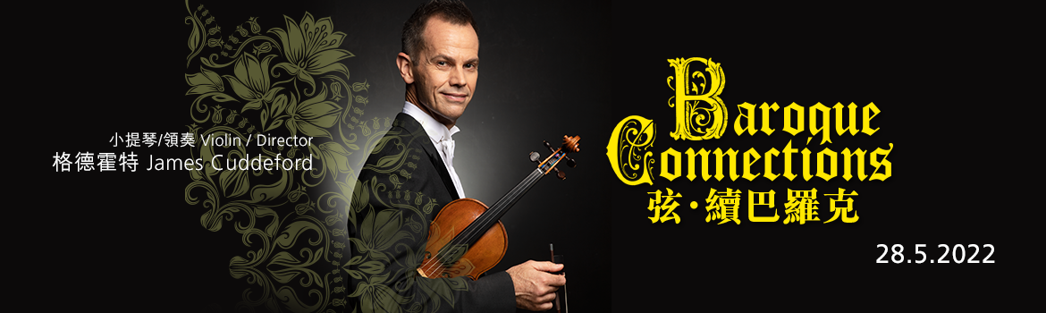

An era of major artistic progress in which music developed to new heights in its complexity and vision, the Baroque period and its unmistakable voice remain intrinsically influential to composers even to this day. In this much-anticipated concert at Hong Kong City Hall Concert Hall on 28 May (Sat) at 8pm, Hong Kong Sinfonietta’s Concertmaster James Cuddeford will direct from the violin some of the most visionary music spanning three centuries, taking you on an illuminating journey through the works of Baroque luminaries like Bach and Vivaldi, as well as other greats such as Haydn and György Kurtág who furthered the Baroque connection.

The first half of the concert is devoted to music written in the late 17th to early 18th century – the Baroque period – opening with Bach’s well-loved Violin Concerto in A minor as Cuddeford takes the centre stage as soloist. Two Vivaldi sinfonias and Purcell’s Chacony in G minor follow, before Biber’s extraordinarily imaginative Battalia brings the first half to a captivating end.

The second half of the concert steps away from the Baroque period and takes us forward in time; English contemporary composer George Benjamin’s “Fantasia 7” – based on the work by his compatriot from the Baroque period Purcell – leads the way, followed by Hungarian composer György Kurtág’s ethereal Ligatura (The Answered Unanswered Question), before Classical giant Haydn’s sparkling Symphony No 59 in A, “Fire” concludes the exhilarating musical journey.

Hong Kong Sinfonietta
Baroque Connections

28 May 2022 (Saturday) 8pm
HK City Hall Concert Hall
$400, $260, $150 (Tickets at URBTIX)

Violin/Director: James Cuddeford

Programme
Bach | Violin Concerto in A minor, BWV1041
Vivaldi | Sinfonia in B minor, RV169, “Al Santo Sepolcro”
Vivaldi | Sinfonia in G, RV146
Purcell | Chacony in G minor
Biber | Battalia
Purcell/George Benjamin | Fantasia 7 (1995)
György Kurtág | Ligatura (The Answered Unanswered Question) (1989)
Haydn | Symphony No 59 in A, “Fire”, Hob I: 59

- Half-price tickets available for full-time students, senior citizens, people with disabilities and their minder, and Comprehensive Social Security Assistance recipients
- 10% discount for group bookings of 4 or more standard tickets
- Suitable for 6 years old or above
- Tickets at URBTIX www.urbtix.hk Enquiries: 3761 6661

*********************************************************************************
James Cuddeford Violin/Director

Currently Concertmaster of the Hong Kong Sinfonietta, James Cuddeford has emerged as one of Australia’s leading musicians. After commencing his musical studies at age seven, he won a full scholarship at age 12 to study at the Yehudi Menuhin School in England. He continued his studies in performance at the Royal Northern College of Music and composition at the University of Manchester. His principal teachers were Yehudi Menuhin in violin, and Karlheinz Stockhausen and György Kurtág in composition. He has won prizes in a series of important competitions including the first prize in the 1996 Charles Hennen International Competition in Holland.

Cuddeford has performed extensively around the world as both soloist and chamber musician. He has frequently appeared at major international festivals in many of the world’s most prestigious halls. As a chamber musician, James has collaborated with artists such as John Lill, Charles Rosen, Stephen Kovacevich, Cristina Ortiz, Michael Collins, Heinz Holliger, Yehudi Menuhin, Bruno Giuranna, Pieter Wispelwey and Michel Dalberto. He has performed concertos with orchestras including the Camerata Lysy Switzerland, BBC Scottish National, Hong Kong Sinfonietta, Jena Philharmonic Germany, Queensland, Adelaide and Tasmanian Symphony Orchestras.

As a highly active and renowned interpreter of contemporary music, Cuddeford has worked with and premiered the music of many of the most important composers of our time, including violin works by Brett Dean, György Kurtág, Roger Smalley and Harrison Birtwistle. At age 15, he was the youngest finalist in the BBC Young Composer of the Year, and the following year the Queensland Philharmonic Orchestra commissioned and premiered his first major orchestral work. His compositions have also been performed, recorded and broadcast in Europe, North America and Asia by groups such as the Nash Ensemble, Australian String Quartet, Ensemble Offspring and Psappha Ensemble. His music is represented by the Australian Music Centre.

Cuddeford joined the internationally acclaimed Australian String Quartet in 1998, and has directed from the violin many orchestras in Australia, Japan and Europe. He lectured in violin at both the Elder Conservatorium and the Australian Institute of Music, and has given masterclasses at many major institutions around the world. He has recorded for ABC Classics, Tall Poppies, Melba Recordings and Toccata Classics and plays on a violin made by Nicolò Gagliano in 1769.

*********************************************************************************
Hong Kong Sinfonietta is financially supported by the Government of the Hong Kong Special Administrative Region

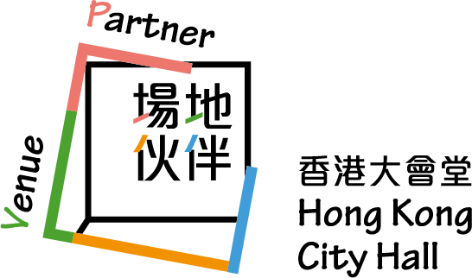

*********************************************************************************
Media Enquiry
Amanda Mok
Senior Marketing & Business Development Manager
Hong Kong Sinfonietta
Email: amanda.mok@hksinfonietta.org
Direct Line: +852 3607 2328
Mobile: +852 9727 1808

