To: Arts/Culture/Features Editor

For immediate release

11 Apr 2023
Press Release

*********************************************************************************
Two French star artists visiting Hong Kong in DOUBLE ACT
to perform with Hong Kong Sinfonietta under Yip Wing-sie
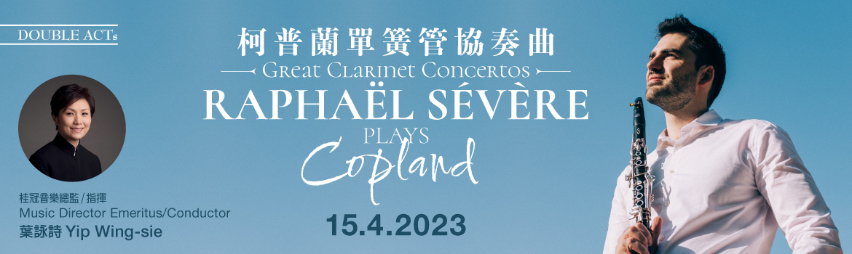

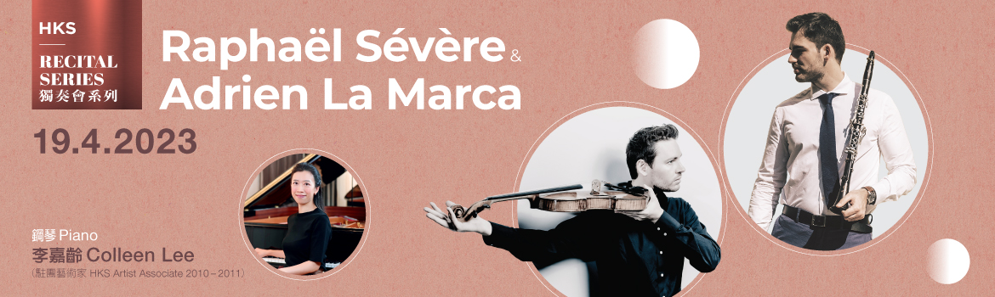

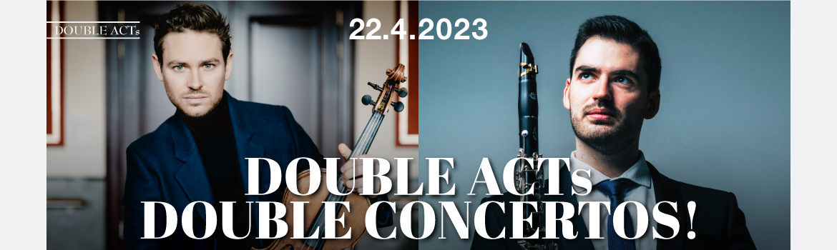

Superstar clarinettist Raphaël Sévère and viola sensation Adrien La Marca will be hailing from France this April and joining Hong Kong Sinfonietta and Music Director Emeritus Yip Wing-sie in three fantastic programmes to kick start the 2023/2024 season! Be it the showstopping fireworks of virtuosic concertos, or the exquisite finesse and intimacy of chamber music, they have it all.

- Great Clarinet Concertos: Raphaël Sévère Plays Copland
15 Apr (Sat) 8pm, Hong Kong City Hall Concert Hall

Since becoming the youngest artist ever nominated for the prestigious Victoires de la Musique Classique “Révélation Soliste Instrumental” award at the age of 15, clarinettist Raphaël Sévère has established himself as one of the youngest yet most celebrated representatives of the French clarinet school. On 15 Apr, he will perform Copland’s signature and beautifully colourful Clarinet Concerto under the baton of Music Director Emeritus Yip Wing-sie. The orchestra will also present Stravinsky’s Concerto in D, strikingly full of character and energy, as well as Mozart’s beloved Symphony No 41 in C, “Jupiter”.

- DOUBLE ACTs: HKS Recital Series
Raphaël Sévère & Adrien La Marca
19 Apr (Wed) 8pm, Hong Kong City Hall Concert Hall

In the more close-knit and intimate setting of a recital, Raphaël Sévère will be joined by French viola sensation Adrien La Marca and pianist Colleen Lee, playing a delightful selection of chamber works by Mozart, Schumann and Poulenc, as well as a beautiful arrangement of Prokofiev's beloved ballet "Romeo and Juliet", promising an evening to remember.

- DOUBLE ACTs: Double Concertos!
22 Apr (Sat) 8pm, Hong Kong City Hall Concert Hall

Raphaël Sévère and Adrien La Marca's DOUBLE ACT will culminate in this spectacular concert with Hong Kong Sinfonietta and Music Director Emeritus Yip Wing-sie. Here, Sévère’s compelling genius will be matched by La Marca’s depth of expression, technical mastery and magnetic stage presence, as the duo presents THREE showstopping concertos by Bruch, Bartók, as well as Sévère himself - in the world première of his new work, Phoenix, which tells the story of a transcendental rebirth, perhaps particularly relevant today as the world is reborn after a devastating pandemic.

Hong Kong Sinfonietta

Great Clarinet Concertos: Raphaël Sévère Plays Copland

15 Apr 2023 (Saturday) 8pm
HK City Hall Concert Hall
$480, $340, $200

Music Director Emeritus/Conductor: Yip Wing-sie
Clarinet: Raphaël Sévère

Programme
Stravinsky | Concerto in D for String Orchestra
Copland | Concerto for Clarinet
Mozart | Symphony No 41 in C, K551, “Jupiter”

HKS Recital Series
Raphaël Sévère & Adrien La Marca

19 Apr 2023 (Wednesday) 8pm
HK City Hall Concert Hall
$420, $280, $160

Clarinet: Raphaël Sévère
Viola: Adrien La Marca
Piano: Colleen Lee (HKS Artist Associate 2010-2011)

Programme
Mozart | Trio for Clarinet, Viola & Piano in E-flat, K498, “Kegelstatt”
Poulenc | Sonata for Clarinet & Piano
Prokofiev/Borisovsky arr | From Romeo and Juliet, Op 64:  Dance of the Knights  Death of Juliet  Mercutio
Schumann | Fairy Tales (Märchenerzählungen) for Clarinet, Viola & Piano, Op 132

DOUBLE ACTs: Double Concertos!

22 Apr 2023 (Saturday) 8pm
HK City Hall Concert Hall
$480, $340, $200

Music Director Emeritus/Conductor: Yip Wing-sie
Clarinet/Composer: Raphaël Sévère
Viola: Adrien La Marca

Programme
Raphaël Sévère | Phoenix for Clarinet, Viola & Orchestra (world première)  Commissioned by Hong Kong Sinfonietta
Bruch | Double Concerto for Clarinet, Viola & Orchestra in E minor, Op 88
Kodály | Dances of Galánta
Bartók | Viola Concerto

- Half-price tickets available for full-time students, senior citizens, people with disabilities and their minder, and Comprehensive Social Security Assistance recipients
- 10% discount for group bookings of 4 or more standard tickets
- Get a 20% off discount when you purchase full-price tickets to any two of the following programmes:
  - Great Clarinet Concertos: Raphaël Sévère Plays Copland (15 Apr)
  - HKS Recital Series: Raphaël Sévère & Adrien La Marca (19 Apr)
  - DOUBLE ACTs: Double Concertos! (22 Apr)
- Suitable for 6 years old or above
- Tickets at URBTIX www.urbtix.hk Enquiries: 3761 6661
- Tickets online (no handling fee) at POPTICKET www.popticket.hk

*********************************************************************************
Yip Wing-sie Music Director Emeritus/Conductor

A highly respected and influential figure in Asia’s orchestral music scene, Yip Wing-sie shifted from being the Music Director of Hong Kong Sinfonietta – a position which she had held since 2002 – to Music Director Emeritus in May 2020. Other positions she had previously held include Principal Conductor and later Music Director of Guangzhou Symphony Orchestra and Resident Conductor of Hong Kong Philharmonic Orchestra.

Winner of the First Prize as well as “Lyre d’Or” in the 35th Concours International de Jeunes Chefs d’Orchestre de Besançon, France in 1985 and a prizewinner in the 8th Tokyo International Conducting Competition in 1988, Yip is in great demand as a guest conductor in Asia. Orchestras she has conducted include the Central Philharmonic Orchestra of China, China National Symphony Orchestra, China Philharmonic Orchestra, Shanghai Symphony Orchestra, Seoul Philharmonic, Osaka Philharmonic, New Japan Philharmonic, Tokyo Mozart Players, the symphony orchestras of Sapporo, Yomiuri, Taiwan, Tasmania, Melbourne and Queensland as well as the Auckland Philharmonia of New Zealand. In Europe, Yip’s engagements have included concerts with the Orchestre National du Capitole de Toulouse and the Chambre Orchestre de Besançon in France, Warsaw Philharmonic in Poland and Spain’s Tenerife Symphony Orchestra. She has also conducted at prestigious venues and festivals such as the Vienna Musikverein (Grossersaal), Beijing Music Festival, Fukuoka’s Asian Month Festival in Japan, Hong Kong Arts Festival and Macao International Music Festival. Yip has collaborated with such renowned artists as Augustin Dumay, Fou Ts’ong, Shlomo Mintz, Anne-Sophie Mutter, Itzhak Perlman and Pinchas Zukerman. Operas she has conducted include Guo Wen-jin’s Poet Li Bai and the world premières of Pierangelo Valtinoni’s opera for children Alice in Wonderland, and La Peintre with Taiwan Philharmonic.

As Music Director of Hong Kong Sinfonietta, Yip has taken the orchestra on tour in recent years to France, Germany, Switzerland, Italy, Poland, Portugal, Lithuania, Canada, the USA, Japan, Korea, Beijing, Shanghai, Taiwan, and in South America in Argentina, Brazil and Uruguay.

Born in Guangzhou and brought up in Hong Kong, Yip graduated from the Royal College of Music in London and the Indiana University at Bloomington, USA, where she obtained her Master’s Degree in violin performance and conducting. As the winner of the Koussevitsky Scholarship and the Seiji Ozawa Fellowship Award, Yip also attended the conducting seminar and fellowship programmes at the Tanglewood Music Center. Her mentors included great maestros such as Norman Del Mar, Leonard Bernstein, Seiji Ozawa, Gustav Meier and David Atherton.

Accolades Yip has received internationally include “Chevalier de l’Ordre National du Mérite” bestowed by the French Government (2015), “Chevalier dans l’Ordre des Arts et des Lettres” by the Ministry of Culture and Communication of France, Fellow of the Royal College of Music (FRCM), and she was also named the Ong Teng Cheong Distinguished Visiting Professor at the Yong Siew Toh Conservatory of Music, National University of Singapore. In Hong Kong, she received an Honorary Fellowship from the Hong Kong Academy for Performing Arts (2022), the “Hong Kong Women of Excellence in the Six Arts Award” from the Hong Kong Federation of Women and the Bronze Bauhinia Star (BBS) from the Hong Kong Government (2013), and was University Artist at The University of Hong Kong (2011- 2012).

*********************************************************************************
Raphaël Sévère Clarinet/Composer

Discovered by the public at the Victoires de la Musique Classique in 2010 when he was nominated for “Révélation Soliste Instrumental” at the age of 15, Raphaël Sévère currently ranks as the youngest representative of the French school of clarinet. His outstanding musical record is highlighted by winning the 1st Prize at the Tokyo International Competition at the age of 12, as well as the 1st Prize and eight (out of 10) Special Prizes of the Young Concert Artists Competition in New York in 2013.

Sévère has made concerto débuts with the Deutsches Symphonie-Orchester at the Berlin Philharmonie, Orchestra of St Luke’s at the Alice Tully Hall in New York, London Philharmonic Orchestra, Konzerthausorchester Berlin, Hong Kong Sinfonietta, Orchestre de Chambre de Paris, Orchestre National Bordeaux Aquitaine, Orchestre National du Capitole de Toulouse, Orchestre National de Lille, Orchestre Symphonique de l’Opéra de Toulon, Orchestre National des Pays de la Loire, Orchestre de l’Opéra de Lorraine, Orchestre de Chambre Nouvelle-Aquitaine, Sinfonia Varsovia etc.

In solo and chamber recitals, Sévère has performed at the Théâtre des Champs-Elysées and Auditorium du Louvre in Paris, Kennedy Center in Washington, Merkin Hall in New York, Isabella Stewart Gardner Museum in Boston, KKL Luzern, Fondazione La Società dei Concerti in Milan, Festspiele Mecklenburg-Vorpommern, French May Arts Festival in Hong Kong, Festival International de Colmar, Menton Festival, Grand Théâtre d’Aix-en-Provence, Festival Musiques en Été in Geneva etc. He has shared the stage with chamber music partners such as the Modigliani, Ébène, Pražák and Van Kuijk quartets, the Wanderer and Messiaen trios, Martha Argerich, Boris Berezovsky, Jean-Frédéric Neuburger, Gidon Kremer, David Grimal, Gérard Caussé, Antoine Tamestit, Gary Hoffman, Xavier Phillips, François Salque and more. He performs regularly with pianist Adam Laloum and cellist Victor Julien-Laferrière, with whom he released an album dedicated to Brahms on the Mirare label which received a Diapason d’Or in 2015.

As a composer, his first work Obscurs for clarinet and guitar was published by Éditions l’Empreinte Mélodique in 2016 and premiered at Salle Cortot in Paris with Antoine Morinière. In 2019, he composed his Seven Miniatures for solo piano and Entre Chien et Loup for solo guitar. In 2020, he wrote his first concerto for clarinet and orchestra, commissioned by the Orchestre National de Bretagne.

Sévère’s recordings on the Mirare label have received the Diapason d'Or, ffff Télérama and Choc-Classica awards. In 2017, he released an album dedicated to Carl Maria von Weber’s first Clarinet Concerto, recorded at the Berlin Philharmonie with the Deutsches Sinfonie-Orchester Berlin under the direction of Aziz Shokhakimov, as well as two of the composer’s other works with pianist Jean-Frédéric Neuburger. Having enjoyed a long and fruitful collaboration with the Trio Messiaen, they released an album in 2018 devoted to the Quatuor Pour la Fin du Temps by Olivier Messiaen, as well as Court Studies from “The Tempest” by Thomas Adès. His latest album is dedicated to Mozart’s Clarinet Concerto and Quintet, recorded with the Orchestre de Chambre de Paris under Lars Vogt, and with the Quatuor Modigliani.

*********************************************************************************
Adrien La Marca Viola

Hailed by The Financial Times as “a truly pure talent” and a “hero” by Le Monde, Adrien La Marca’s playing is characterised by depth of expression and technical mastery with a rich, deep, burnished quality to his sound. Gifted with a charismatic stage presence and the ability to create an immediate emotional connection with his audience, he is considered one of today’s most compelling musicians.

As a soloist, La Marca has performed with renowned orchestras such as the Orchestre National de France, Orchestre Philharmonique de Radio France, MDR Leipzig Radio Symphony Orchestra, Polish National Radio Symphony Orchestra, Hong Kong Sinfonietta, Orchestre Philharmonique Royal de Liège (Artist in Residence 2018-2019), Insula Orchestra, Les Siècles, Orchestre National du Capitole de Toulouse and Orchestre National de Metz Grand Est, among others.

Named “Révélation Soliste Instrumental” in 2014 by Victoires de la Musique Classique, La Marca has since performed in prestigious venues such as the Paris Philharmonie, Auditorium du Louvre, Théâtre des Champs-Elysées, Théâtre de la Ville de Paris, Salle Gaveau, London Barbican Centre and Wigmore Hall, Amsterdam Concertgebouw, Berlin Konzerthaus, Schloss Elmau and Vienna Musikverein, as well as at festivals such as the Festival de Pâques d’Aix-en-Provence, La Folle Journée, Salzburg Festival, Schleswig-Holstein Music Festival, Jerusalem Festival, Festspiele Mecklenburg-Vorpommern, Schubertiade Hohenems and Schwarzenberg Festival.

Last season’s highlights include debuting at the Hamburg Elbphilharmonie with the Ensemble Resonanz and several concerts at international festivals with renowned musicians such as Sol Gabetta, Patricia Kopatchinskaja and Bertrand Chamayou at Solsberg Festival, and Daniel Hope and Pinchas Zukerman at Schleswig-Holstein Music Festival. This season, concerts are planned at the Paris Philharmonie, Théâtre des Champ-Elysées, La Seine Musicale, Berlin Pierre Boulez Saal and London Wigmore Hall.

Released in 2016 on the label La Dolce Volta, La Marca’s first album English Delight has received critical acclaim from The Strad, Gramophone, Strings Magazine, Le Monde, Le Figaro, Diapason, Classica etc, and was awarded the Diapason d'Or, ffff Télérama, Coup de Coeur FNAC, as well as named Editor’s Choice on Gramophone. His latest album released in 2020 on the same label, HEROES, features the Walton Viola Concerto with Orchestre Philharmonique Royal de Liège, a world première of Gwenaël Mario Grisi’s Viola Concerto expressly written for him, and Prokofiev’s Romeo and Juliet – the first time this work has been recorded for solo viola and orchestra.

Born in Aix-en-Provence, France in 1989 to a family of musicians, La Marca began playing the piano and viola at the age of four. He entered the Paris Conservatoire at 16 and studied under Jean Sulem. He completed his studies in Leipzig with Tatjana Masurenko and later in Berlin with Tabea Zimmermann. During his studies, he was regularly invited to take part in various music academies and had the opportunity to work with inspiring musicians such as Seiji Ozawa, Valery Gergiev, Gidon Kremer, András Schiff and Menahem Pressler. In 2016, he was the first classical musician to receive a grant from the prestigious Fondation Jean-Luc Lagardère. He is also supported by Fondation Banque Populaire, L’Or du Rhin and the Safran Foundation. He has won numerous prizes in international competitions including the William Primrose, Lionel Tertis and Johannes Brahms competitions.

La Marca plays a Nicola Bergonzi viola made in Cremona.

*********************************************************************************
Colleen Lee Piano/HKS Artist Associate 2010/2011

Since winning the 6th Prize at the 15th International Frederic Chopin Piano Competition, Colleen Lee has performed extensively throughout Asia, Europe and North America in solo recitals and with orchestras such as the Israel Philharmonic Orchestra, Warsaw Philharmonic Orchestra, Galacia Royal Philharmonic Orchestra, Sendai Philharmonic Orchestra, China Philharmonic Orchestra, Guangzhou Symphony Orchestra, Wuhan Philharmonic Orchestra, Shanghai Symphony Orchestra, Hong Kong Sinfonietta and Hong Kong Philharmonic, among others. Lee was the Artist Associate of Hong Kong Sinfonietta in 2010/2011, and has toured with the orchestra in South America, Italy and Taiwan.

She has also been a featured artist at several international music festivals including the International Chopin Festival in Duszniki and Gdansk in Poland, Assisi International Piano Festival in Italy, Meissen Pianoforte Festival in Germany, International Keyboard Festival in New York, Bowdoin International Music Festival and Musicus Fest in Espoo, Finland. Her performance of the “Magic Piano and Chopin Shorts” animation series at the 42nd Hong Kong Arts Festival had garnered rave review. She was invited to perform twice in the “Beethoven Piano Sonatas Marathon” in Vienna and Hong Kong. She appeared as soloist with the Hong Kong New Music Ensemble in the 2018 Shanghai New Music Week. In 2019, she made her début with London Symphony Orchestra under Simon Rattle.

As an enthusiastic chamber musician, Lee frequently appears in chamber music concerts and has also collaborated with world-famous instrumentalists including violinists Ning Feng and Kang Dong-suk, cellists Trey Lee, Daniel Müller-Schott and Alexander Kniazev, trumpet virtuoso Sergei Nakariakov, and the Shanghai Quartet. She is also a member of the RTHK Chamber Soloists which was formed in 2018.

Born in Hong Kong, Lee started her piano lessons at the age of four. Subsequently she was trained at the Hong Kong Academy for Performing Arts (HKAPA) under Eleanor Wong and at the Hochschule für Musik, Theater und Medien in Hannover with Arie Vardi. She won the First Prize at the 3rd Seiler International Piano Competition in Kitzingen, Germany, the 2003 Dorothy Mackenzie Artist Recognition Award, Third Place and Critic and Audience Prizes at the 15th International Competition for Piano and Orchestra in Cantú, Italy, and was a prizewinner at the 1st Hong Kong International Piano Competition, the Pro Musicis International Award, Gina Bachauer International Artist Competition, Sendai International Music Competition, and the 16th Santander International Piano Competition in Spain.

Lee’s discography includes an all-Chopin album recorded on the Pleyel Piano released by the Fryderyk Chopin Institute, and a complete Scarlatti Sonatas album by Naxos. She was also featured on the Hong Kong Sinfonietta DECCA album This is Classical Music 3.

In recognition of Lee’s outstanding achievements in music and in the promotion of arts and culture, she has been awarded Certificate of Commendation by the Secretary of Home Affairs, Commendation for Community Service by the Hong Kong Government and Young Artist Award by the Hong Kong Arts Development Council.

Currently Lee is the Honorary-Artist-in-Residence of The Education University of Hong Kong and on the piano faculty of HKAPA and Hong Kong Baptist University.

*********************************************************************************
Hong Kong Sinfonietta is financially supported by the Government of the Hong Kong Special Administrative Region



*********************************************************************************
Media Enquiry
Amanda Mok
Senior Marketing & Business Development Manager
Hong Kong Sinfonietta
Email: amanda.mok@hksinfonietta.org
Direct Line: +852 3607 2328
Mobile: +852 9727 1808

