To: Arts/Culture/Features Editor

For immediate release

2 Feb 2024
Press Release

*********************************************************************************
Japanese drumming sensation Senri Kawaguchi
debuts with Hong Kong Sinfonietta in Fly LIVE!
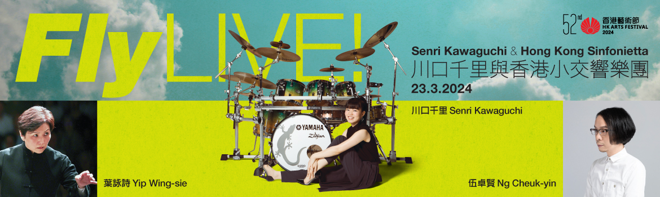

Always passionate about expanding the horizons of classical music and exploring cross-genre possibilities, Hong Kong Sinfonietta is collaborating with Japanese drumming sensation Senri Kawaguchi this Hong Kong Arts Festival to present local composer Ng Cheuk-yin’s Fly LIVE! and An Array of Stars for drumset and orchestra, under the baton of Music Director Emeritus Yip Wing-sie and joined by acclaimed Japanese bass guitarist Shingo Tanaka. Tickets to the concert, which takes place at Hong Kong City Hall Concert Hall on 23 Mar (Sat) at 8pm, are now on sale at URBTIX.

Premiered at the Hong Kong Arts Festival in 2007, award-winning local composer/HKS Artist Associate (2006-2008) Ng Cheuk-yin’s Fly for drumset and orchestra shattered boundaries at the time – not only the one between pop and symphonic classical music, but later the social boundaries imposed in 2020 during the COVID pandemic when Hong Kong Sinfonietta reinvented the work into Project FLY, a recorded performance released online and joined remotely by young Japanese drumming sensation Senri Kawaguchi. Widely recognised as one of the world’s top drummers, Kawaguchi’s astonishing virtuosity and breathtaking energy can finally be experienced live now, as she makes her live début with Hong Kong Sinfonietta to perform the newest version of Ng’s Fly – renamed Fly LIVE! – as well as the world première of An Array of Stars, under the baton of Music Director Emeritus Yip Wing-sie. They will be joined on stage by leading bass guitarist Shingo Tanaka, who has worked closely with the renowned jazz fusion band T-Square and recently recorded the soundtrack for the acclaimed animated film BLUE GIANT.

The exciting programme also features two monumental works by two of the greatest American composers of all time – Barber’s well-loved Adagio for Strings and Copland’s effervescent Appalachian Spring.

The 52nd Hong Kong Arts Festival
Fly LIVE!
Senri Kawaguchi & Hong Kong Sinfonietta

23 Mar 2024 (Saturday) 8pm
Hong Kong City Hall Concert Hall
$520, $380, $280, $200

Music Director Emeritus/Conductor: Yip Wing-sie
Drumset: Senri Kawaguchi
Bass guitar: Shingo Tanaka
Composer: Ng Cheuk-yin (HKS Artist Associate 2006-2008)

Programme
Barber | Adagio for Strings
Copland | Appalachian Spring
Ng Cheuk-yin | Fly LIVE! for Drumset & Orchestra  Commissioned by Hong Kong Sinfonietta
Ng Cheuk-yin | An Array of Stars for Drumset & Orchestra (world première)  Commissioned by Hong Kong Sinfonietta

- Half-price tickets available for full-time students, senior citizens, people with disabilities and their minder, and Comprehensive Social Security Assistance recipients
- 10% discount for group bookings of 4 or more standard tickets
- Suitable for 6 years old or above
- Tickets at URBTIX www.urbtix.hk Enquiries: 3761 6661
- Tickets online (no handling fee) at POPTICKET www.popticket.hk

*********************************************************************************
Ng Cheuk-yin Composer/HKS Artist Associate 2006-2008)

Composer, music producer, sheng performer and a cappella artist Ng Cheuk-yin is Hong Kong Sinfonietta’s first Artist Associate (2006-2008), Music Director of fusion group SIU2 and Artistic Director of a cappella theatre company Yat Po Singers.

After receiving a post-graduate degree from the Music Department of the Chinese University of Hong Kong, Ng went on to study Japanese at the International Christian University in Tokyo and Jazz Music at Codarts in the Netherlands.

In 2012, Ng was named “Artist of the Year (Music)” at the 2012 Hong Kong Arts Development Awards. In 2009, 2013 and 2022, he received the “Best Serious Composition” award at the CASH Golden Sail Music Awards for his theatrical choral work Rock Hard, double sheng concerto Before the City Collapses (commissioned by Hong Kong Sinfonietta) and Chinese orchestral work Ji respectively. His choral work Singing Voices of the World was also awarded “Most Performed Work (Serious Music)” twice.

Ng’s orchestral works include the drumset concerto Fly, double sheng concerto Before the City Collapses and percussion concerto White etc, as well as works for Chinese orchestra such as Tang Resonating, sheng concerto The Seventh Month etc.

Ng’s recent works include Playground, a fusion orchestra-video performance commissioned by No Limits of the Hong Kong Arts Festival; music for dance drama spectaculars L'Amour Immortel, Lady White of West Snake, Di Zi Gui etc; film score for the McDull movie Pork of Music; choral works Before We Grow Up, Music of Love; and pop songs Under the Cherry Blossom Tree and The Way We Grew by Hins Cheung, and Can’t Get Happy by Eason Chan etc. In 2011 and 2018, Ng released the a cappella albums Single Singers and Two Is Better Than One. In early 2022, he launched the “Yat Yat Yat Kids Song” NFT project.

*********************************************************************************
Hong Kong Sinfonietta is financially supported by the Government of the Hong Kong Special Administrative Region

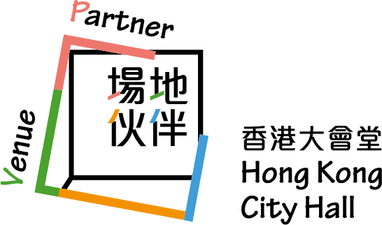

*********************************************************************************
Media Enquiry
Amanda Mok
Senior Marketing & Business Development Manager
Hong Kong Sinfonietta
Email: amanda.mok@hksinfonietta.org
Direct Line: +852 3607 2328
Mobile: +852 9727 1808

