To: Arts/Culture/Features Editor

For immediate release

17 Jul 2024
Press Release

*********************************************************************************
Get to know the human behind the genius in Hong Kong Sinfonietta’s
all-Beethoven programme with conductor Jason Lai & pianist Colleen Lee
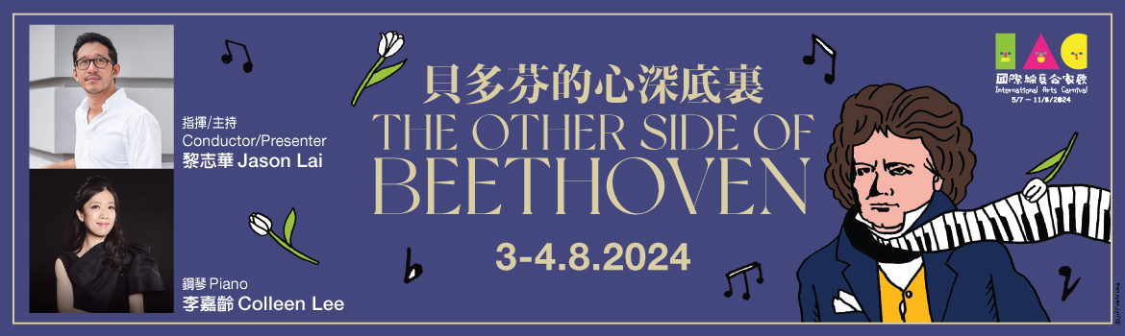

“I would have put an end to my life — only Art it was that withheld me”, wrote Beethoven in an unsent letter to his brothers where he confessed his deepest vulnerabilities. Now hailed as one of the greatest and most influential composers of all time, Beethoven lived a life that was far from glamorous or easy. In the face of various professional, personal, financial and health setbacks, how did he manage to power through and create some of the most monumental and revolutionary works of music ever written?

This International Arts Carnival 2024, Hong Kong Sinfonietta presents The Other Side of Beethoven, where conductor Jason Lai – former Associate Conductor of the orchestra and seasoned television presenter with the BBC – will join hands with star pianist Colleen Lee to present a selection of the composer's most iconic works, and share with you the intriguing and lesser-known facets of Beethoven's life, showing you his story of perseverance which remains ever-important and relevant.

The Other Side of Beethoven (presented in English) will take place on 3 & 4 Aug (Sat & Sun) at Tuen Mun Town Hall Auditorium; tickets are now on sale at URBTIX and POPTICKET.

Currently Principal Conductor at the Yong Siew Toh Conservatory in Singapore, Jason Lai was formerly Associate Conductor of the Singapore Symphony Orchestra and Hong Kong Sinfonietta, where he was also HKS Artist Associate from 2009 to 2011. He has also built a unique reputation as an educator and communicator with mass appeal, making frequent appearances on BBC television including the BBC Young Musician of the Year competition, Classical Star, Maestro, How a Choir Works and The Culture Show. In this return to Hong Kong, he will conduct excerpts from some of the best loved symphonies by Beethoven – No 2, No 3 “Eroica”, No 5, No 6 “Pastoral” and No 9 “Choral”
– as well as Piano Concerto No 3 in C minor starring Colleen Lee, who will also perform excerpts from the composer’s other popular piano works.

Download photos and press release: https://t.ly/ongz9

International Arts Carnival 2024
Hong Kong Sinfonietta
The Other Side of Beethoven

3 Aug 2024 (Saturday) 7:30pm
4 Aug 2024 (Sunday) 3pm
Tuen Mun Town Hall Auditorium
$400, $260, $150
(Presented in English)

Conductor/Presenter: Jason Lai (HKS Artist Associate 2009-2011)
Piano: Colleen Lee (HKS Artist Associate 2010-2011)

All-Beethoven programme
Piano Concerto No 3 in C minor, Op 37
and excerpts from:
Symphony No 2 in D, Op 36
Symphony No 3 in E-flat, Op 55, “Eroica”
Symphony No 5 in C minor, Op 67
Symphony No 6 in F, Op 68, “Pastorale”
Symphony No 9 in D minor, Op 125, “Choral”
and other piano concertos

- Half-price tickets available for full-time students, senior citizens, people with disabilities and their minder, and Comprehensive Social Security Assistance recipients
- 10% discount for group bookings of 4 or more standard tickets
- Suitable for 6 years old or above
- Tickets at URBTIX www.urbtix.hk Enquiries: 3761 6661
- Tickets online (no handling fee) at POPTICKET www.popticket.hk

*********************************************************************************
Jason Lai Conductor/Presenter/HKS Artist Associate 2009-2011

Jason Lai is Principal Conductor at the Yong Siew Toh Conservatory in Singapore, and former Associate Conductor of the Singapore Symphony Orchestra and Hong Kong Sinfonietta, where he was also HKS Artist Associate from 2009 to 2011. He has been a prominent figure in Singapore’s musical life since his arrival in 2010, while also actively giving international masterclasses in Europe and China. He has appeared as guest conductor with the New Japan Philharmonic, Osaka Symphony Orchestra, Podlaskie Opera and Philharmonic, Adelaide Symphony Orchestra, Macao Orchestra and Thailand Philharmonic Orchestra.

Intent on broadening the appeal of classical music to audiences who would not normally think of going into a concert hall, Lai is also building a unique reputation as a communicator with mass appeal through his television appearances in both the UK and Asia. He has frequently appeared on BBC television as a judge in both the BBC Young Musician of the Year competition and the classical talent show Classical Star. He reached his widest audience when, as a conducting mentor in the series Maestro, his celebrity student – the popular comedienne Sue Perkins – won with a nail-biting final in front of the BBC Concert Orchestra and a live studio audience. Other BBC television appearances included How a Choir Works and The Culture Show. He also starred in Clash for the children’s television channel, CBBC.

Lai has continued with his television work since settling in Singapore. He was presenter and conductor for Project Symphony, an eight-part series for OKTO where he was filmed setting up a community orchestra. He has been heavily involved in filming for a BBC series Heart of Asia which explores the contemporary arts and culture scene in Thailand, Indonesia, Korea and the Philippines, and a further series for BBC World called Tales from Modern China. His most recent work is for Channel News Asia and includes Sing to Remember, a documentary on dementia and singing in choirs, and Nudge, a five-part series on how we can be persuaded to change our daily habits.

Lai’s roots lie in Hong Kong but he was born in the UK and was a pupil at the prestigious specialist music school in Manchester, Chetham’s, where he studied cello. At Oxford University he studied both cello and composition, and he went on to the Guildhall School of Music and Drama in London where he was awarded a Fellowship in Conducting.

Despite having toured as a cellist with the Allegri String Quartet and having been a finalist in the BBC Young Composers Award, Lai gravitated increasingly towards conducting after he won the BBC Young Conductors Workshop in 2002. This led to his appointment as Assistant Conductor to the BBC Philharmonic with whom he made his BBC Proms début in 2003.

Education is an important part of Lai’s work in Singapore. At the Yong Siew Toh Conservatory, he trains the next generation of conductors, many of whom have had many successes both at home and abroad, and with the SSO he spearheaded the education and outreach programme, helping the orchestra reach new audiences notably through his Discovering Music and children’s concert series.
*********************************************************************************
Colleen Lee Piano/HKS Artist Associate 2010-2011

Since winning the 6th Prize at the 15th International Frederic Chopin Piano Competition, Colleen Lee has performed extensively throughout Asia, Europe and North America in solo recitals and with orchestras such as the Israel Philharmonic Orchestra, Warsaw Philharmonic Orchestra, Galacia Royal Philharmonic Orchestra, Sendai Philharmonic Orchestra, China Philharmonic Orchestra, Guangzhou Symphony Orchestra, Wuhan Philharmonic Orchestra, Shanghai Symphony Orchestra, Hong Kong Sinfonietta and Hong Kong Philharmonic, among others. Lee was the Artist Associate of Hong Kong Sinfonietta in 2010/2011, and has toured with the orchestra in South America, Italy and Taiwan. Last season, she made multiple appearances alongside leading international artists in the HKS Recital Series, and performed with the orchestra in Shenzhen at China’s largest outdoor music festival – the Lian Hua Shan Glades Music Festival – under the baton of Music Director Emeritus Yip Wing-sie.

Lee has been a featured artist at several international music festivals including the International Chopin Festival in Duszniki and Gdansk in Poland, Assisi International Piano Festival in Italy, Meissen Pianoforte Festival in Germany, International Keyboard Festival in New York, Bowdoin International Music Festival and Musicus Fest in Espoo, Finland. Her performance of the “Magic Piano and Chopin Shorts” animation series at the 42nd Hong Kong Arts Festival had garnered rave review. She was invited to perform twice in the “Beethoven Piano Sonatas Marathon” in Vienna and Hong Kong. She appeared as soloist with the Hong Kong New Music Ensemble in the 2018 Shanghai New Music Week. In 2019, she made her début with London Symphony Orchestra under Simon Rattle.

As an enthusiastic chamber musician, Lee frequently appears in chamber music concerts and has also collaborated with world-famous instrumentalists including violinists Ning Feng and Kang Dong-suk, cellists Trey Lee, Daniel Müller-Schott and Alexander Kniazev, trumpet virtuoso Sergei Nakariakov, and the Shanghai Quartet. She is also a member of the RTHK Chamber Soloists which was formed in 2018.

Born in Hong Kong, Lee started her piano lessons at the age of four. Subsequently she was trained at the Hong Kong Academy for Performing Arts (HKAPA) under Eleanor Wong and at the Hochschule für Musik, Theater und Medien in Hannover with Arie Vardi. She won the First Prize at the 3rd Seiler International Piano Competition in Kitzingen, Germany, the 2003 Dorothy Mackenzie Artist Recognition Award, Third Place and Critic and Audience Prizes at the 15th International Competition for Piano and Orchestra in Cantú, Italy, and was a prize winner at the 1st Hong Kong International Piano Competition, the Pro Musicis International Award, Gina Bachauer International Artist Competition, Sendai International Music Competition, and the 16th Santander International Piano Competition in Spain.

Lee’s discography includes an all-Chopin album recorded on the Pleyel Piano released by the Fryderyk Chopin Institute, and a complete Scarlatti Sonatas album by Naxos. She was also featured on the Hong Kong Sinfonietta DECCA album This is Classical Music 3.

In recognition of Lee’s outstanding achievements in music and in the promotion of arts and culture, she has been awarded Certificate of Commendation by the Secretary of Home Affairs, Commendation for Community Service by the Hong Kong Government and Young Artist Award by the Hong Kong Arts Development Council. Currently Lee is the Honorary-Artist-in-Residence of The Education University of Hong Kong and on the piano faculty of HKAPA and Hong Kong Baptist University.

*********************************************************************************
In collaboration with
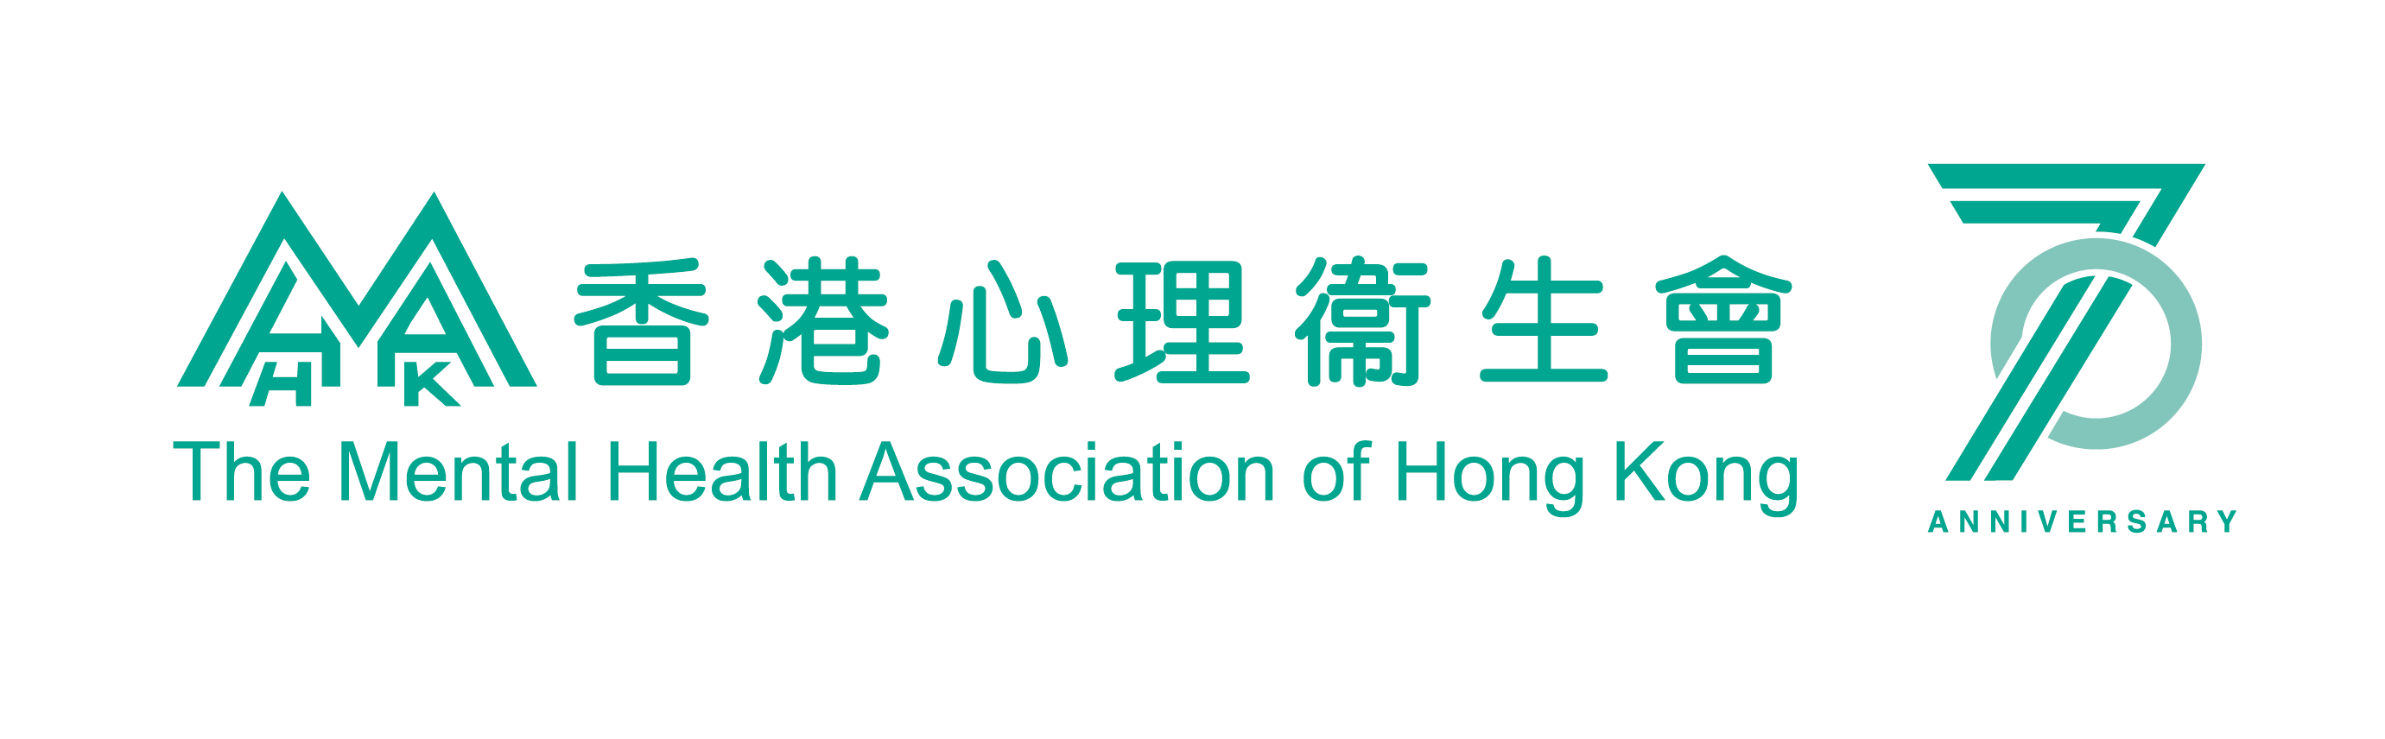

*********************************************************************************
Hong Kong Sinfonietta is financially supported by the Government of the Hong Kong Special Administrative Region



*********************************************************************************
Media Enquiry
Amanda Mok
Senior Marketing & Development Manager
Hong Kong Sinfonietta
Email: amanda.mok@hksinfonietta.org
Direct Line: +852 3607 2328
Mobile: +852 9727 1808

