To: Arts/Culture/Features Editor

For immediate release
8 Aug 2024
Press Release
*******************************************************************************************
Hong Kong Sinfonietta presents ground-breaking celebration of
Chinese and Australian musical heritage
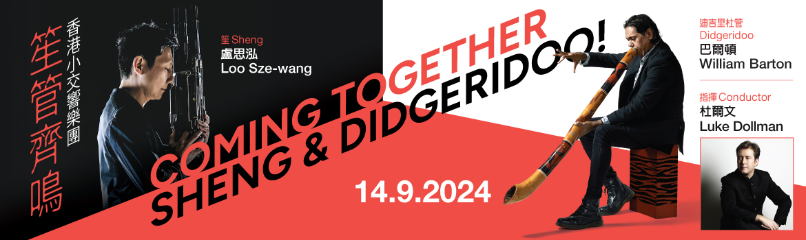

Widely recognised and lauded for its innovative programming, Hong Kong Sinfonietta continues to reimagine and reinvent the possibilities of classical music with this one-of-a-kind, ground-breaking cultural crossover bringing together two world-leading virtuosos of two unique, fascinating and surprisingly versatile traditional wind instruments. Representing home soil is local sheng master Loo Sze-wang, while didgeridoo superstar William Barton will hail from Australia and bring into spotlight the incredible thousand-year-old instrument which has become a shining beacon of Australian Aboriginal culture. The pair will present the world première of Dylan Crismani’s concerto for Sheng and Didgeridoo, Coming Together, under the baton of conductor Luke Dollman on 14 Sep (Sat) at Hong Kong City Hall Concert Hall; tickets are now on sale at URBTIX.

Named Queensland Australian of the Year in 2023 and making his Hong Kong début in this concert, William Barton is Australia’s didgeridoo superstar who first started learning the ancient instrument from his uncle who was an elder of the Wannyi, Lardil and Kalkadunga people. Now active internationally as a highly esteemed instrumentalist, composer and vocalist, he has performed with and been commissioned by the Berlin Philharmonic, London Philharmonic, Bremer Philharmonic, 2008 Beijing Olympic Committee etc, and has vastly expanded the horizons of the didgeridoo, an exquisite Aboriginal instrument typically made of hardwood and hand-decorated with traditional paints.

The foremost sheng virtuoso of his generation in Hong Kong, Loo Sze-wang is a major advocate of the 3000-year-old instrument historically performed to emperors and guests at banquets and celebrations; his masterful performances have impressed audiences around the world in Argentina, Australia, Brazil, Canada, the USA, Japan, Taiwan, Germany, Singapore, Korea and China. As Hong Kong Sinfonietta’s Artist Associate in the 2012/2013 season, he toured with the orchestra in North America and returns this September for a spectacular showcase of cross-cultural harmony.

Under the baton of Luke Dollman, the orchestra will also present Beethoven’s well-loved Symphony No 7 and Egmont Overture, as well as the Hong Kong première of Australian composer Peter Sculthorpe’s Earth Cry, a mesmerising piece depicting the vast and distinct landscape of Australia.

Download photos and press release: https://www.dropbox.com/scl/fo/q4z8foy5l6ohibkniehfo/AEhV-fDOUsba2bsvAN462QU?rlkey=3ozcvae6vhfbmfc7n6eo1auou&dl=0

Hong Kong Sinfonietta
Coming Together – Sheng & Didgeridoo!

14 Sep 2024 (Saturday) 8pm
Hong Kong City Hall Concert Hall
$480, $340, $200

Conductor: Luke Dollman
Sheng: Loo Sze-wang (HKS Artist Associate 2012-2013)
Didgeridoo: William Barton

Programme
Beethoven | Egmont Overture, Op 84
Peter Sculthorpe | Earth Cry (abridged version, 1999) (Hong Kong première)
Dylan Crismani | Coming Together for Sheng & Didgeridoo (world première)
Beethoven | Symphony No 7 in A, Op 92

- Half-price tickets available for full-time students, senior citizens, people with disabilities and their minder, and Comprehensive Social Security Assistance recipients
- 10% discount for group bookings of 4 or more standard tickets
- Suitable for 6 years old or above
- Tickets at URBTIX www.urbtix.hk Enquiries: 3761 6661
- Tickets online (no handling fee) at POPTICKET www.popticket.hk

***********************************************************************************

Luke Dollman Conductor

Luke Dollman began his musical life as a violinist, performing professionally with orchestras on both modern and Baroque violin. After deciding to focus on conducting, he furthered his studies at the renowned Sibelius Academy in Helsinki, gaining a Master of Music degree with Leif Segerstam and Jorma Panula, as well as studying at the Aspen Music Festival as a Fellow with David Zinman. He was a participant in the inaugural Allianz International Conductors’ Academy in 2004, studying with Kurt Masur and working with the London Philharmonic Orchestra in the process. In 2000, he was awarded First Prize at the Symphony Australia Westfield Conducting Competition hosted by the Melbourne Symphony Orchestra.

A recipient of the Bernard Haitink Scholarship, Dollman held the position of Assistant Conductor to Edo de Waart at the Netherlands Radio Philharmonic Orchestra from 2001-2003. During this time, he performed with the orchestra regularly, conducting public performances for national radio and television. In 2005, Dollman made his UK début with the BBC National Orchestra of Wales in a main series concert which was broadcast on BBC Radio 3, and has since returned to them many times for concerts and recordings. A laureate of the Besançon International Competition for Young Conductors, he made his French début conducting the Monte-Carlo Philharmonic Orchestra for the opening concert of the Besançon Festival in 2009. 2011 saw his German début with the Nordwestdeutsche Philharmonie. Other orchestras he has worked with include the Royal Scottish National Orchestra, Helsinki Philharmonic Orchestra, Oulu Sinfonia, Sinfonietta de Lausanne, Pori Sinfonietta, Hong Kong Sinfonietta, Brabants Orkest, Holland Symfonia, Belgian National Orchestra, Welsh National Opera Orchestra, Malaysian Philharmonic Orchestra, Helsingborgs Symphony Orchestra, Gävle Symphony Orchestra, Odense Symphony Orchestra, New Zealand Symphony Orchestra, Auckland Philharmonia, Christchurch Symphony Orchestra and all of Australia’s professional orchestras.

Having earlier worked as an assistant at the Dutch National Opera, Dollman made his opera début at Opera Australia with Mozart’s Le Nozze di Figaro in 2004 and was immediately reinvited to conduct Die Zauberflöte. In 2005, he made his Finnish National Opera début with Puccini’s Manon Lescaut to great acclaim, and has since returned regularly to conduct works such as La Rondine, Rigoletto, The Taming of the Shrew and the world première of Lera Auerbach’s Cinderella. 2011 saw Dollman make his début with State Opera South Australia conducting Bizet’s Les Pêcheurs de Perles, and he has since returned to conduct Die Zauberflöte, Don Pasquale and Dido and Aeneas. In 2018, he released his first CD on the Decca label with soprano Greta Bradman and the Adelaide Symphony Orchestra.

Dollman has guest conducted regularly at leading conservatories such as the Guildhall School of Music, Royal Conservatoire The Hague, Sydney Conservatorium of Music, Yong Siew Toh Conservatory of Music and Sibelius Academy. He is also a recognised authority in the field of conductor training, and has taught at the Sibelius Academy, Royal Conservatoire of Scotland, University of Adelaide and the masterclasses of Symphony Services International. He is currently Associate Professor of Conducting and Deputy Director of the Elder Conservatorium of Music at the University of Adelaide.
***********************************************************************************
Loo Sze-wang Sheng/HKS Artist Associate 2012-2013

Loo Sze-wang is a prize-winning and the foremost sheng (Chinese mouth-organ) virtuoso of his generation in Hong Kong, championing both traditional and contemporary repertoires. Equally active as soloist and chamber musician, he has been featured several times at the Hong Kong Arts Festival, the contemporary music festival Musicarama and Radio Television Hong Kong. His performances have been heard in Argentina, Australia, Brazil, Canada, the USA, Japan, Taiwan, Germany, Singapore, Korea and China.

Frequently collaborating with contemporary composers, Loo performed in Chan Hing-yan’s chamber opera Heart of Coral during Hong Kong Week 2014 in Taipei, Law Wing-fai’s music theatre When Petals Fall in Serenity, and Samson Young’s The Anatomy of Musician in Paris. In the 2012/2013 season, Loo was Artist Associate of Hong Kong Sinfonietta and toured with the orchestra in North America. He gave the world première of Chan Hing-yan’s Hark the Phoenix Solitaire Cry with Orchestra UniMi in Milan under the baton of Yip Wing-sie in 2016, and Hong Kong Odyssey commissioned by the Hong Kong Arts Festival the following year. His solo recital “Listen to the Sphinx”, organised by the Hong Kong New Music Ensemble, was held in 2023.

In 2024, the Chinese University of Hong Kong and University of Notre Dame in the USA jointly invited Loo and violinist Patrick Yim to perform two concerts of five newly commissioned works, and record them for an album. The University of Hawaii appointed Loo as Artist-in-Residence in the same year, debuting compositions on campus. He also gave a solo recital in the Chamber Resonance series organised by RTHK Radio 4. In November, Loo will work with conductor Luke Dollman again in Adelaide to perform the world première of the sheng concerto Mountains, Clouds, Streams by Stephen Whittington.

Loo co-founded Chinese Music Virtuosi, a Chinese instrumental ensemble of six players, with the aim to promote traditional and contemporary Chinese music. They were Ensemble-in-Residence of the Chinese University of Hong Kong in 2011/2012.

A graduate of The Chinese University of Hong Kong and The Hong Kong Academy for Performing Arts, Loo received tutelage from Chen De-ren and Cheng Tak-wai. He also took flute lessons with Timothy Wilson and Chan Kwok-chiu.

******************************************************************************************

William Barton Didgeridoo

William Barton is widely recognised as Australia’s leading didgeridoo player as well as a highly esteemed composer, instrumentalist and vocalist. He has composed works for didgeridoo, orchestra, string quartet, jazz band and rock band, and taken part in collaborative projects with some of Australia’s leading composers. He first started learning the instrument from his uncle Arthur Peterson, an elder of the Wannyi, Lardil and Kalkadunga people. His mother Delmae Barton – a singer, songwriter and poet – also encouraged his love of music, introducing him to traditional dance groups, fusion/rock/jazz bands, orchestras, string quartets and mixed ensembles from an early age.

Barton’s passion lies in creating a journey for people through music and presenting them with a diversity of musical styles. He utilises his cultural heritage and storytelling to engage audiences in the uniqueness of Australia, its Aboriginal heritage and to challenge perspectives of the didgeridoo as an instrument. He works closely with classical music composers to preserve and expand the horizons of didgeridoo music, inspiring composers such as Peter Sculthorpe, Ross Edwards, Elena Kats-Chernin, Matthew Hindson and Liza Lim to write for him. He is active as a soloist as well as collaboratively with orchestras, string quartets, mixed ensembles, traditional dance groups and fusion/rock/jazz bands. He has performed at historic events including the 2019 Commonwealth Day at Westminster Abbey before the British Royal Family, Anzac Cove in Gallipoli, State Memorial Service of Bob Hawke and International Jazz Day with Herbie Hancock and James Morrison.

Majors commissions which Barton has received throughout his diverse career include writing for members of the Berlin Philharmonic, Sydney Symphony Orchestra and Queensland Symphony Orchestra, as well as contemporary dance companies and dancers such as Leigh Warren and Dancers, for which the work Breathe was premiered at both WOMADelaide and the Edinburgh International Festival in 2012. In 2008, the Beijing Olympics Opening Ceremony committee commissioned Barton as one of the three composers for the Australian segment of the ceremony, which was broadcast to a worldwide audience.

In 2022, Barton won two Screen Music Awards, an ARIA award and AACTA award for his soundtrack with the Australian Chamber Orchestra for the film River. In 2021, he was the recipient of the prestigious Don Banks Music Award from the Australia Council for the Arts. His other awards include Best Original Score for a Mainstage Production at the 2018 Sydney Theatre Awards, as well as Best Classical Album and an ARIA award for Birdsong At Dusk in 2012. He has released five albums on the ABC Classics label, including recently Heartland with Véronique Serret and the words of Delmae Barton.

Barton holds honorary doctorates from both Griffith University and the University of Sydney, and was the Artist in Residence at Melbourne Recital Centre in 2019. He is an Associate Professor at the Australian National University and a Creative Consultant for Australia Day Live at the Sydney Opera House. He has a strong desire to give back to his culture, people and community; one of his greatest enjoyments is his involvement in workshops with schools and children all over Australia, where he teaches didgeridoo and storytelling to the next generation.

Barton was named Queensland Australian of the Year in 2023, putting him in the running for Australian of the Year. He is currently developing a new musical language in partnership with Delmae Barton and Véronique Serret.

******************************************************************************************
With support from
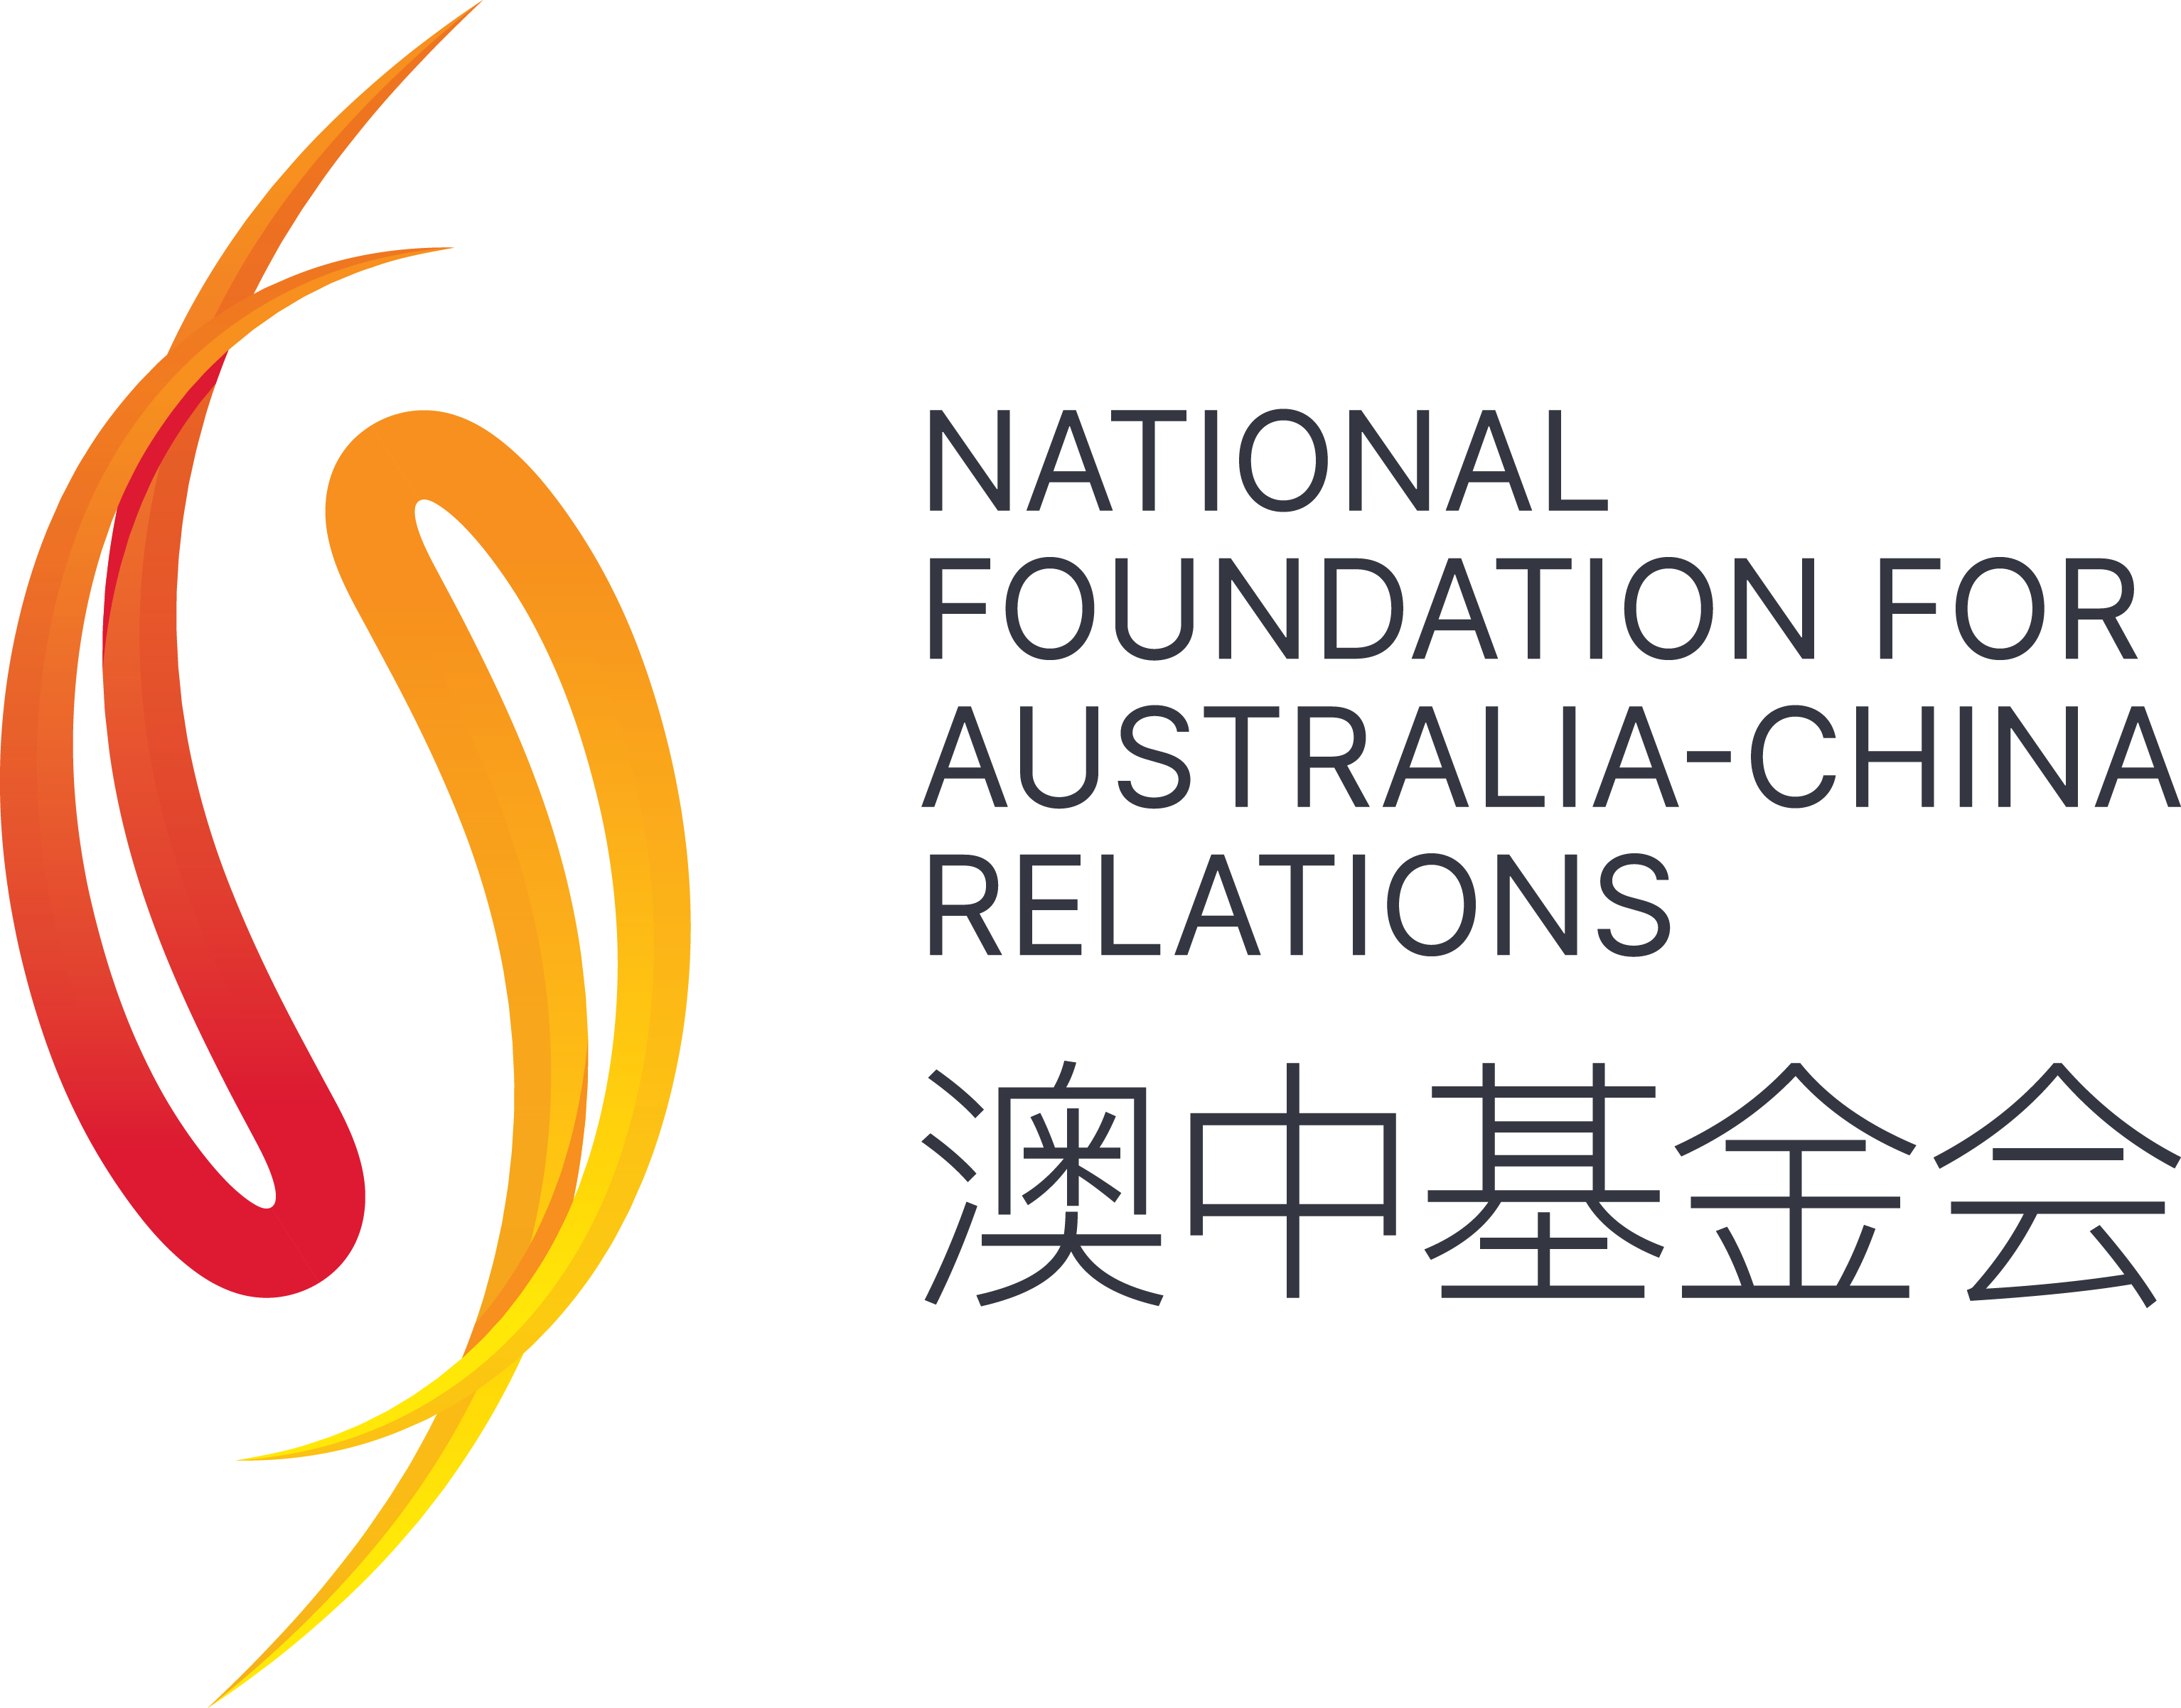
******************************************************************************************
Hong Kong Sinfonietta is financially supported by the Government of the Hong Kong Special Administrative Region

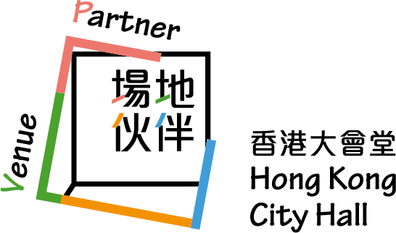

******************************************************************************************
Media Enquiry
Amanda Mok
Senior Marketing & Development Manager
Hong Kong Sinfonietta
Email: amanda.mok@hksinfonietta.org
Direct Line: +852 3607 2328
Mobile: +852 9727 1808

